Algebra 1 Classwork Name _________________________________________________________________

Modeling and Residual Plots Period ________

The table below shows the value of a rare baseball card $y,$ in dollars, and the time in years, $x,$ since the card was purchased by a collector.

$$x$$ | 1 | 2 | 3 | 4 | 5 | 6 | 7
$$y$$ | 1800 | 2040 | 2400 | 2825 | 3275 | 3900 | 4500

Part A: Use linear regression to write an equation that models the relationship between the value of the card and the time in years. Round the slope and the y-intercept to the nearest integer. Record the correlation coefficient to the nearest hundredth. What does the correlation coefficient suggest about how well a linear model fits the data? Explain.

Part B: What do the slope and the slope and the y-intercept represent in the context of the problem?

Part C: Sketch the residual plot for the data on the axes below. What does the residual plot suggest about how well the linear model fits the data? Explain your reasoning.

Part D: Use exponential regression to write an equation that models the relationship between the value of the card and the time in years. Round the parameters to the nearest integer. What do the $a$ and $b$ values in your equation represent in the context of the problem?

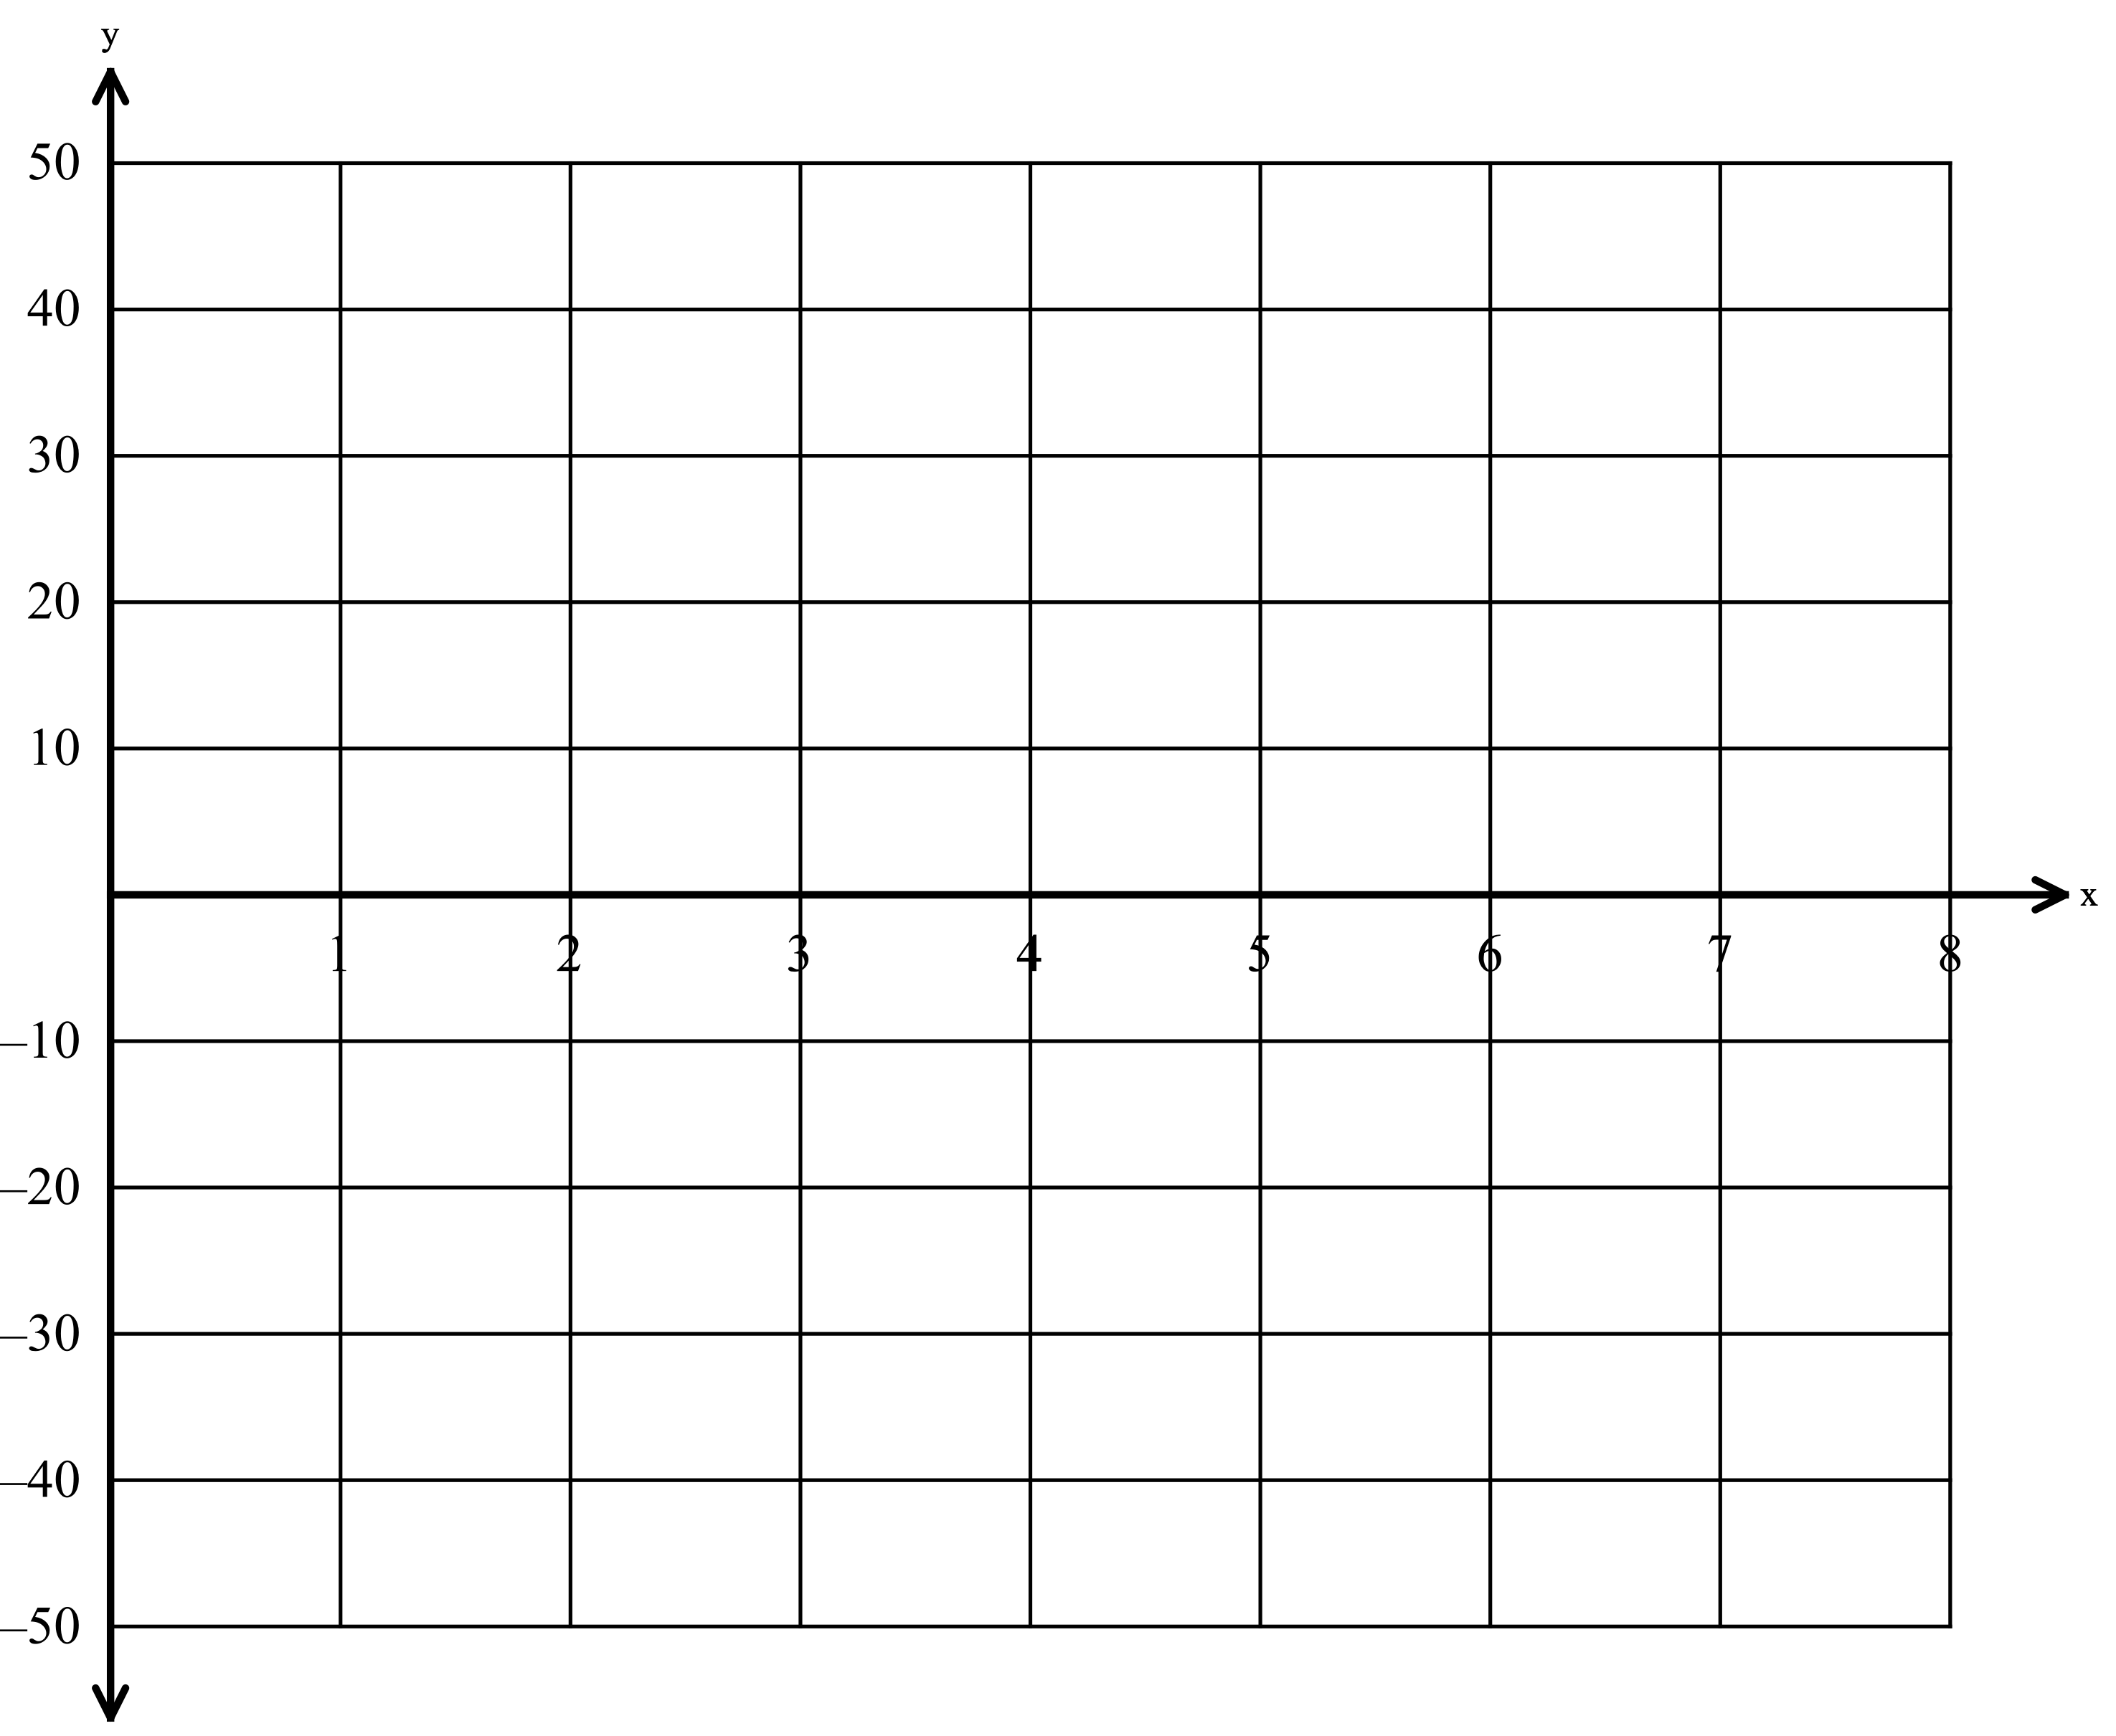
Part E: Construct a residual plot of the data on the axes provided. What does the residual plot suggest about how well the exponential model fits the data? Explain your reasoning.

Part F: The actual value of the baseball card 25 years after the initial purchase was $74,500. Use your linear and exponential models to find the predicted value of the card after 25 years. Which one does the better job of predicting the value of the card over time? Explain.

