Algebra II





Regents

Review

**Functions**

**Notation:** f(x) “take whatever is in parentheses and put it in for x”

**Domain:** input values, x-values

**Range:** output values, y-values

**Vertical Line Test:** x-values do not repeat therefore function

**Horizontal Line Test:** determines one-to-one and whether or not the function’s inverse is a function

**One-to-one:** x and y values do not repeat

**Onto:** entire range is used

**Even:** f(-x) = f(x), symmetry over y-axis

**Odd:** f(-x) = -f(x), symmetry through the origin, looks the same upside down

**Inverses:** Switch x and y, then solve for new y; reflection in y = x

**Piecewise Functions:** Defined differently on specific intervals

**Transformations: y = a f(b(x ± c)) ± d**

a < 0, reflection in the x-axis

|a| > 1, vertical stretch

|a| < 1, vertical compression

b < 0, reflection in the y-axis

|b| > 1, horizontal compression of 1/|b|

|b| < 1, horizontal stretch of 1/|b|

c > 0, phase shift left c

c < 0, phase shift right c

d > 0, up d

d < 0, down

**Regressions:** Stat, Edit, Calc, pick regression and compare **correlation coefficient**, r if linear, if not r2

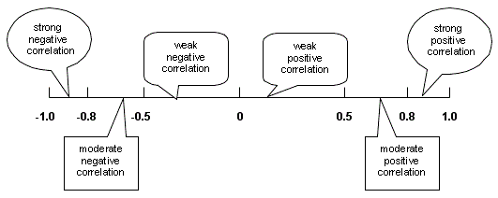0 ≤ r ≤ 1

**Average Rate of Change** = $\frac{f\left(b\right)-f(a)}{b-a}=$ slope = $\frac{∆y}{∆x}=\frac{y_{2}-y_{1}}{x_{2}-x_{1}}$

Graphs and “Shells”

Constant Function Linear Function Absolute Value

y = c y = mx + b or y – y1 = m(x – x1) y = ___|x____|___

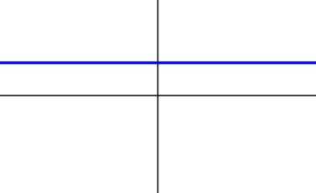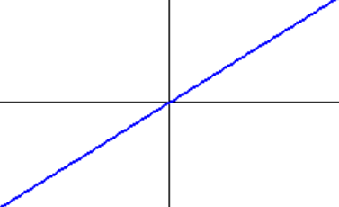

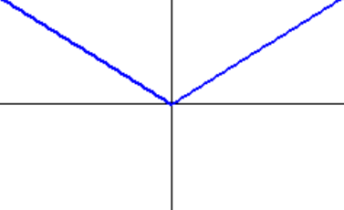

Quadratic {Even Polynomial} Circle {not a function} Cubic {Odd Polynomial}

y = ___(x___)2 + ___ (x – h)2 + (y – k)2 = r2 y = ___(x___)3 + ___

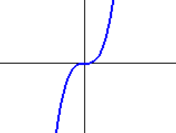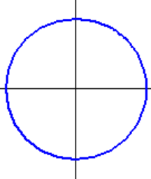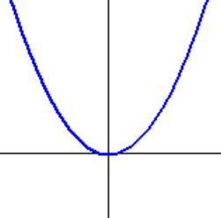

Rational Function Even Radical Odd Radical

$y= ___\left(\frac{1}{x___}\right)+___$ y = $\sqrt[even]{x___}$___ + ___ y = $\sqrt[odd]{x___}$___ + ___

Or y = ${\left(x___\right)}^{\frac{1}{even}}$__ + _____ Or y = ${\left(x___\right)}^{\frac{1}{odd}}$__ + _____

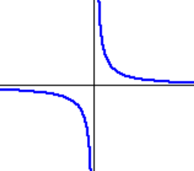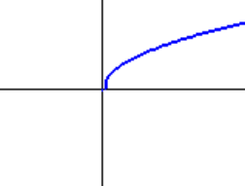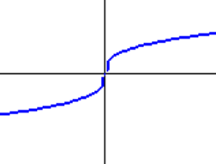

Exponential Function Logarithmic Function

y = ___a__(x___) + ___ y = ___loga(x____) + ___

Growth Decay

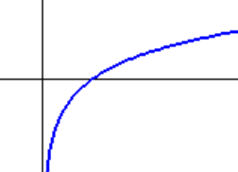

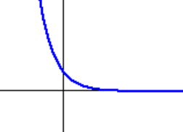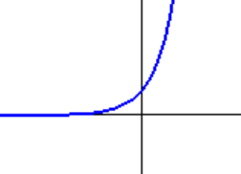

Sine Function Cosine Function Tangent Function

y = ___sin(___(x___)) + ___ y = ___cos(___(x___)) + ___ y = ___tan(___(x___)) + ___

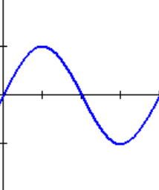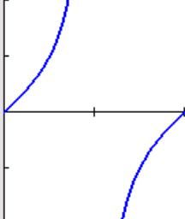

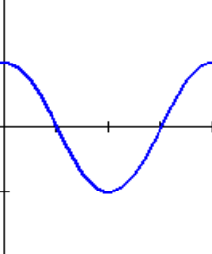

**Systems of Equations**

Linear, Linear Linear, Quadratic, Circle 3 Equations, 3 Variables

[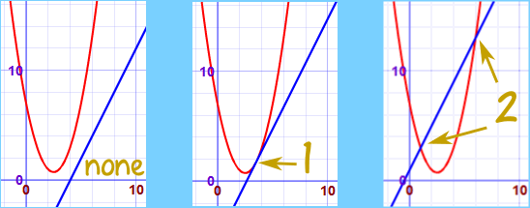](http://www.google.com/url?sa=i&rct=j&q=&esrc=s&source=images&cd=&cad=rja&uact=8&ved=0ahUKEwi_wvvAyr7MAhXKVj4KHWL0BiwQjRwIBw&url=http://www.mathsisfun.com/algebra/systems-linear-quadratic-equations.html&bvm=bv.121070826,d.cWw&psig=AFQjCNHH7D5WKRocDcOPTGd-AkuTWEO1cA&ust=1462388115824444)[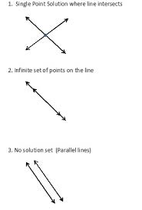](https://www.google.com/imgres?imgurl=http://www.jleemack.com/uploads/6/7/9/7/6797819/1733959_orig.jpg&imgrefurl=http://www.jleemack.com/systems-of-equations.html&docid=OCbmQTF9aEOGWM&tbnid=aK1aEphZOReS8M:&w=317&h=468&safe=strict&bih=847&biw=1264&ved=0ahUKEwjwg7-vyb7MAhXDPz4KHYnJASwQMwhYKBQwFA&iact=mrc&uact=8)

Remember to use matrices to check your answer!

**[A]-1[B]**

[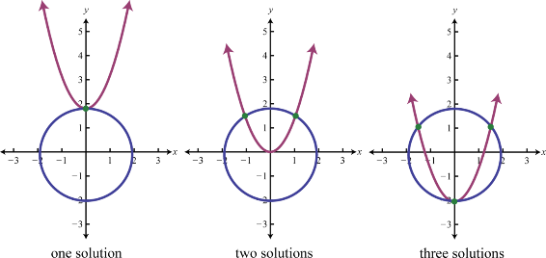](http://www.google.com/url?sa=i&rct=j&q=&esrc=s&source=images&cd=&cad=rja&uact=8&ved=0ahUKEwiBhrHkyr7MAhUEGj4KHdeaBTUQjRwIBw&url=http://catalog.flatworldknowledge.com/bookhub/10121?e%3Dfwk-redden-ch08_s05&bvm=bv.121070826,bs.1,d.cWw&psig=AFQjCNGsR23zVpf1bCcZzT3NfZj6RHuVFA&ust=1462388199066613)

**Quadratic Functions**

**Standard Form: Factored Form Vertex Form**

f(x) = ax2 + bx + c f(x) = a(x – r1)(x – r2) f(x) = a(x – h)2 + k

aos: aos: $x= \frac{r_{1}+r_{2}}{2}$ aos: $x=h$

y-int: (0, c) y-int: (0, f(0)) y-int: (0, f(0))

x-int: x-int: (r1, 0) (r2, 0)

vertex: $\left(\frac{-b}{2a}, f\left(\frac{-b}{2a}\right)\right)$ vertex: $\left(\frac{r_{1}+r_{2}}{2}, f\left(\frac{r_{1}+r_{2}}{2}\right)\right)$ vertex: (h, k)

Locus definition of a **parabola**: the set of points equidistant from a fixed point, **focus**, and a fixed line, **directrix**.

p = distance between the focus and the directrix, also the distance between the focus and the vertex, 4p = focal width

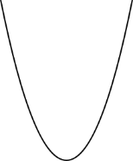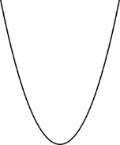

p > 0 p < 0 p > 0 p < 0

**(x – h)2 = 4p(y – k) (y – k)2 = 4p(x – h)**

vertex: (h, k) vertex = (h, k)

focus: (h, k + p) focus: (h + p, k)

directrix: y = k – p directrix: x = h – p

aos: x = h aos: y = k

Solving Quadratics: 1) Set equation = 0

2) Factor, Complete the Square, or Quadratic Formula

[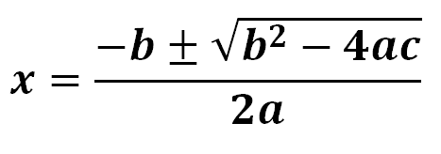](http://www.google.com/url?sa=i&rct=j&q=&esrc=s&source=images&cd=&cad=rja&uact=8&ved=0ahUKEwiD-uWHx8PMAhXJ4D4KHXlvBhMQjRwIBw&url=http://www.statisticslectures.com/topics/quadraticformula/&psig=AFQjCNGH0ZTaIUWgLLIqx1_3B5X7FCqTwQ&ust=1462559011125937)

**Circle: (x – h)2 + (y – k)2 = r2 x2 + y2 = r2**

Center: (h, k) Center: (0, 0)

Radius = r Radius = r

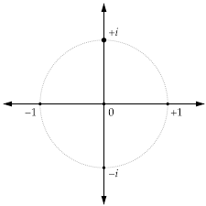 **Powers of i: $i= \sqrt{-1}$**  yi (imaginary)

i0 = 1, i1 = i, i2 = -1, i3 = -I, …

**conjugate** of a + bi = a - bi x (real)

**Factoring:**  What do they have in common?

**Difference of two perfect squares**, the factors are conjugate pairs: x2 – y2 = (x + y)(x – y)

**Sum of two perfect squares**, the factors are imaginary conjugate pairs: x2 + y2 = (x + yi)(x – yi)

**Four Square Method**

**Grouping:** split, factor, factor, factor

**Chunking:** u-substitution

**Sum of two perfect cubes:** (x3 + y3) = (x + y)(x2 – xy + y2)

**Difference of two perfect cubes:** (x3 - y3) = (x - y)(x2 + xy + y2)

**Perfect Trinomial Square:** (x + y)2 = x2 + 2xy + y2 and (x - y)2 = x2 - 2xy + y2

Given Roots, find equation: **x2 – (sum)x + product = 0**

**Complete the square:**

1) To rewrite quadratic f(x) = ax2 + bx + c in vertex form

2) To solve a quadratic equation ax2 + bx + c = 0

3) To rewrite ax2 + bx + cy + d = 0 or ay2 + by + c x + d = 0 in vertex form

4) To rewrite circle equation, ax2 + ay2 + bx + cy + d = 0 in standard for

**Nth Degree Polynomials**

**Even Degree Polynomials** **Odd Degree Polynomials**

End Behavior: same End Behavior: opposite

Extrema: minimum # = 1 Extrema: minimum # = 0

maximum # = n – 1 maximum # = n – 1

**Global vs. Local Extrema**: Global is for entire function, Local refers to all turning points

Always use the **x-values** when determining **intervals** where the function is increasing or decreasing.

If (x – c) is a factor of the polynomial, x = c is a root of the polynomial. Use your calculator to find the rational roots then use long division and the quadratic formula to find the others

**Factor Theorem:** If f(c) = 0, then (x – c) is a factor of the polynomial.

**Remainder Theorem:** Since p(x) = (x – c)Q(x) + R, **p(c) = R** In other words, when a polynomial is divided by (x – c), the remainder equals p(c).

**Multiplicity of Roots:** **even** when graph is tangent to the x-axis, **odd** when crossing the x-axis

**Pythagorean Triples:** Start with any two positive numbers; Add their squares, Subtract their squares, Double their product

**Rational Functions**

**Simplifying/Multiplying/Dividing:** Factor all numerators and denominators then Bing! Remember, when you divide, first you have to flip it then multiply.

**Adding/Subtracting Rational Expressions:** Put each “piece” over the LCD, adjust the numerators and combine like terms. “If there is no equal sign, keep it a fraction all the time.”

**Rational Equations:** Multiply each “piece” by $\frac{LCD}{1}$ to clear the fractions, then solve, but… BEWARE OF EXTRANEOUS ROOTS

**Word Problems:**

Concentration Work Average Cost d = rt

%(Amt) + %(Amt) = %(Amt) $\frac{1}{{time}_{1}}+\frac{1}{{time}_{2}}=\frac{1}{{time}_{total}}$ $Avg Cost= \frac{Overhead+unit(x)}{x}$

**Radicals and Exponents**

**Solving Radical Equations:**  1) Isolate the radical

2) Raise each side to the reciprocal power

3) When raising to an even root, remember the ±

4) BEWARE OF EXTRANEOUS ROOTS

**Simplifying Radical Expressions:** 1) Break down the number into prime factors

2) For each group of “n”, one comes out of the radical

**Exponential Equations:** 1) Isolate the exponential part

2) If like bases set exponents =, otherwise take ln or log of

each side

**Properties of Exponents:**

1. Anything to the zero power = 1 x0 = 1

2. A negative exponent means reciprocal x-a =  also,  = xa

3. A fractional exponent is a radical x= 

4. When multiplying **like** bases, add exponents. xaxb = xa+b

5. When raising an exponent to a power, multiply the exponents. ** =** xab

6. When dividing **like** bases, subtract exponents.  = xa-b

**Exponential Formulas:**

Exponential Growth/Decay Compound Interest Continuous Growth

$y={A(1 ±r)}^{t}$ $y=P{\left(1+\frac{r}{n}\right)}^{nt}$ $y=Pe^{rt}$

**Logarithmic Equations:**  1) Use Properties of Logarithms to **condense** equation.

2) Exponentiate each side and solve new equation.

**Logarithmic Properties:**

1. The log of a product is the sum of the logs. **logb xy = logb x + logb y**

2. The log of a quotient is the difference of the logs. **logb  = logb x - logb y**

3. The log raised to a power is the power times the log. **logb xy = y logb x**

**Sequences and Series**

**Arithmetic** (common difference) **Geometric** (common ratio)

Recursive Rule: an = an-1 + d an = (an-1)r

Explicit (General) Rule: **an = a1 + d(n-1) an = a1(r)n-1**

Sum of n terms: $s_{n}=\frac{n\left(a_{1}+a_{n}\right)}{2}$ $s_{n}=\frac{a_{1}\left(1-r^{n}\right)}{1-r}$

**Trigonometry Function Transformations: y = A trig(B(x ± C)) ± D**

**|A| = Amplitude |B| = Frequency C is the phase shift right or left D is the midline**

**Amplitude** is the distance from a high point to the midline: $A= \frac{High y - Low y}{2}$

**Frequency** is the number of cycles in 2π

For sine and cosine B = for tangent =

**Period** is the length of one cycle



sine and cosine = tangent =

**Midline** is the vertical shift up or down: $D= \frac{High y + Low y}{2}$

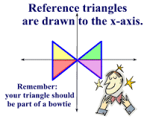**More Trigonometry!**

SOH CAH TOA

1 degree = 60 minutes

1 minute = 60 seconds

π radians = 180 degrees



radians → degrees multiply by



degrees → radians multiply by

Special Right Triangles

30:60:90 45:45:90

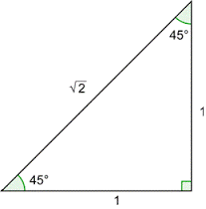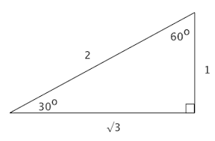



sin θ = cos θ = tan θ =

**Arc Length**: s = r θ {θ is in radians}

**Unit Circle (x,y) → (cos θ,sin θ)**

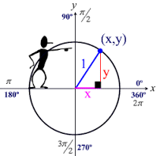

**S A**

**T C**

**Reference Angles**

Quad I: ref θ = θ

Quad II: ref θ = 180° - θ

Quad III: ref θ = θ - 180°

Quad IV: ref θ = 360° - θ

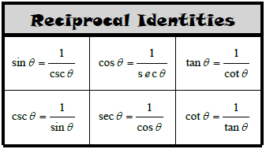

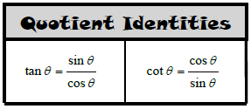

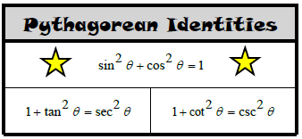

**Probability**

Venn Diagrams/Two-Way Tables/Hypothetical 1000 Tables

Relative Frequency: Probability as a decimal

**Formulas:**

Complement {Ac, A’, $\overline{A}$}: P($\overline{A}$) = 1 – P(A)

Addition {OR}: P(A U B) = P(A) + P(B) – P(A ∩ B)

Mutually Exclusive {Disjoint}: P(A ∩ B) = 0

Multiplication {AND}: P(A ∩ B) = P(A) · P(B|A)

Conditional Probability: P(A|B) = $\frac{P(A ∩ B)}{P(B)}$

Independent events: P(A ∩ B) = P(A) · P(B) Or P(A|B) = P(A)

**Statistics**

Sample Mean: $\overline{x}$ Population Mean: **µ**

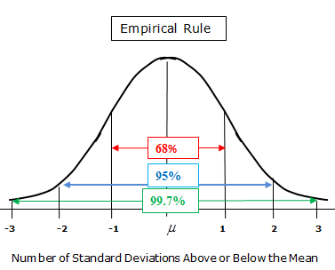 Sample Standard Deviation: **Sx** Population Standard Deviation: **σx**

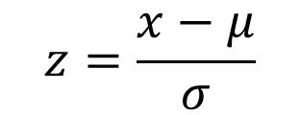**z-scores:** the number of standard deviations

above or below the mean

Find **Area** with **Normalcdf**(low, high, µ, σ)

Find **Scores** with **InvNorm**(area, µ, σ)

**Statistical Studies:**

Observational (Record Observations) Survey(Questions) Experiment(Cause and Effect)

**Sample Proportion: $\hat{p}=\frac{\# of successes}{ n}$** , n = sample size

**Margin of Error and 95% Confidence Intervals: Statistical Significance:**

**Population Proportion Population Mean 1)** A result outside a 95% confidence interval

 **2)** If confidence intervals **do not** overlap