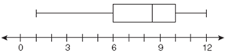**1 Variable Statistics and Box Plots**

**The 5 numbers you need for a box plot are:**

**minx – The Lowest Number**

**Q1 – The middle of the first half of the data (The 25th percentile)**

**Median – The middle number (The 50th percentile)**

|  |  |  |  |  |
| --- | --- | --- | --- | --- |
|  | | | | |
|  |  |  |  |  |
| **Press the Stat key** | **Choose “Edit” by pressing Enter** | **Enter data into** | **Stat Calc**  **Choose 1-Var Stats** | **Scroll down to the bottom** |

**Q3 – The middle of the second half of the data (The 75th percentile)**

**maxX – The highest number**

**Three other useful numbers that the calculator gives you are:**

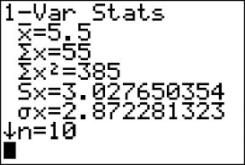

The mean (average)

The sum of the numbers

The amount of numbers you entered in L1

The Range – (not given on the calculator) maxX – minX which is the highest minus the lowest