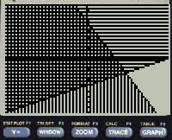

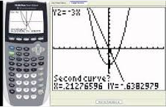

**Common Core Algebra 1**

**Regents Exam Calculator Skills**

**Name:**

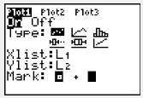

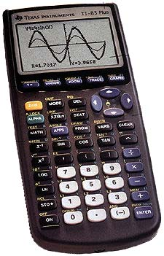

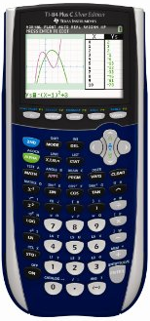

This booklet contains most of the TI-83/TI-84 Graphing Calculator skills that you need to know how to do prior to taking the Common Core Algebra 1 Regents Examination.

**Table of Contents**

**Reset the Calculator......................................................... page 2**

**Resetting the Graphing Window............................................ page 2**

**Finding Factors of a Number............................................... page 2**

**Finding the Greatest Common Factor...................................... page 2**

**Checking Factors............................................................ page 2**

**Reducing Fractions.......................................................... page 2**

**Checking Solutions to Equations & Inequalities............................ page 3**

**Finding the Coordinates of a Vertex....................................... page 3**

**STATISTICS**

**Box – Plot................................................................... page 4**

**Scatter Plot................................................................. page 4**

**Linear Regression............................................................ page 4**

**Correlation Coefficient...................................................... page 5**

**Exponential Regression...................................................... page 5**

**Quadratic Regression...................................................... page 5**

**Residuals..................................................................... page 6**

**Graphing Residuals........................................................... page 6**

**SYSTEMS**

**Finding the Points of Intersection.......................................... page 7**

**Graphing Systems of Inequalities.......................................... page 7**

|  |  |
| --- | --- |
| **Reset the Graphing Window** | |
|  |  |
| **Press Zoom** | **Choose 6:ZStandard**  **Press Enter** |

|  |  |
| --- | --- |
| **Reset the Calculator** | |
|  |  |
| **Press 2nd +**  **to go to Memory** | **Press 7 1 2** |

|  |  |
| --- | --- |
| **Find GCF(Greatest Common Factor)** | |
|  |  |
| **Press 2nd 0**  **to go to Catalog**  **gcd is same as GCF** | **Enter both numbers with a comma in between** |

|  |  |
| --- | --- |
| **Find Factors of a Number** | |
|  |  |
| **Press y = and enter the # divided by x** | **Press 2nd Graph**  **to go to the Table** |

|  |  |
| --- | --- |
| **Reducing Fractions** | |
|  |  |
| **Enter Fraction as**  **-8 divided by 12** | **Press Math then Enter Enter** |

|  |  |
| --- | --- |
| **Checking Factors** | |
|  |  |
| **Press y = and enter expression & factors into**  **and** | **Press 2nd Graph**  **to go to the Table.**  **If all of the outputs from both are identical, then the factors are correct** |

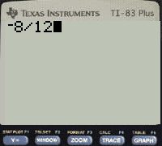

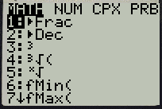



|  |  |  |  |  |
| --- | --- | --- | --- | --- |
|  |  |  |  |  |
|  |  |  |  |  |

|  |  |  |
| --- | --- | --- |
| **Checking Solutions to Equations and Inequalities** | | |
|  |  |  |
| **Store the value you are checking by pressing**  **8 STO> Enter** | **Enter your equation or inequality by pressing**  **2nd Math & selecting the correct symbol.** | **Press Enter**  **“1” means True**  **“0” means False** |

|  |  |  |  |
| --- | --- | --- | --- |
| **Finding Coordinates of a Vertex** | | | |
|  |  |  |  |
| **Press y = and enter Quadratic Function** | **Press 2nd Calc**  **Choose “minimum” or “maximum”** | **Choose a “left bound” – a point to the left of the vertex and a “right bound” a point to right of the vertex. Press Enter** | **Coordinates of Vertex**  **(-3,-1)** |

**Statistics**

|  |  |  |  |  |
| --- | --- | --- | --- | --- |
| **Box-Plot** | | | | |
|  |  |  |  |  |
| **Press the Stat key** | **Choose “Edit” by pressing Enter** | **Enter data into** | **Stat Calc**  **Choose 1-Var Stats** | **Scroll down to the bottom** |

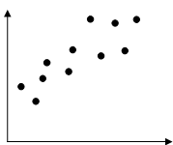

|  |  |  |  |  |
| --- | --- | --- | --- | --- |
| **Scatter Plot** | | | | |
|  |  |  |  |  |
| **Press Stat Enter** | **Enter x-values in**  **and y-values in** | **2nd y =**  **to go to StatPlot** | **Turn Plot1 On** | **Set the Window and the press Graph** |

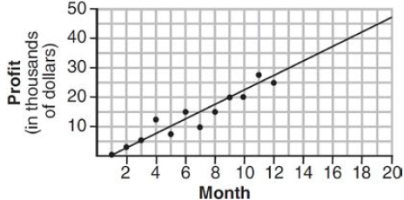

|  |  |  |  |
| --- | --- | --- | --- |
| **Equation of Line of Best Fit**  **Linear Regression** | | | |
|  |  |  | **Equation of the Line of Best Fit is** |
| **Press Stat** | **Arrow right to Calc**  **Choose 4:LinReg(ax+b)** | **Press Enter** |  |

|  |  |  |  |
| --- | --- | --- | --- |
| **Correlation Coefficient (r-value) tells you Strong, Moderate or Weak correlation** | | | |
|  |  |  |  |
| **Press 2nd Catalog**  **go to DiagnosticOn** | **Press Enter**  **make sure it says Done** | **Stat Arrow right to Calc Choose 4:LinReg(ax+b)** | **The r-value is the Correlation Coefficient** |

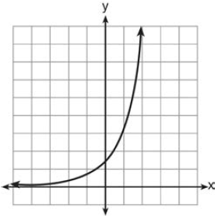

|  |  |  |  |
| --- | --- | --- | --- |
| **Exponential Regression** | | | |
|  |  |  | **Exponential Equation is** |
| **Press Stat** | **Arrow right to Calc**  **Choose 0:ExpReg** | **Press Enter** |  |

|  |  |  |  |
| --- | --- | --- | --- |
| **Quadratic Regression** | | | |
|  |  |  | $$y=1.07x^{2}+0.14x-3.49$$ |
| **Press Stat** | **Arrow right to Calc**  **Choose 5:QuadReg** | **Press Enter** |  |

|  |  |  |  |  |
| --- | --- | --- | --- | --- |
| http://www.shodor.org/media/M/T/l/mYzliZjY4ZDc0NjI3YWQ3YWVlM2MzZmUzN2MwOWY.jpg    **Residuals** | | | | |
|  |  |  |  |  |
| **Press the Stat key** | **Choose “Edit” by pressing Enter** | **Enter data into** **&** | **Stat Calc**  **Choose “LinReg (ax+b)”** | **Press Enter** |
|  |  |  |  |  |
| **Go back to your lists by pressing Stat & choosing “Edit”** | **Highlight** **and press Enter** | **Press 2nd Stat and choose “RESID”** | **Press Enter** | **The residuals for each point will appear in** |

|  |  |  |  |
| --- | --- | --- | --- |
| **Graphing Residuals** | | | |
|  |  |  |  |
| **2nd Stat Plot**  **Choose “Plot 1” by pressing Enter** | **Turn on Plot 1 by highlighting “On” and pressing Enter** | **Change Ylist to “RESID” by pressing**  **2nd Stat** | **Press Zoom**  **and choose Option 9 “ZoomStat”** |

**Systems**

|  |  |  |  |
| --- | --- | --- | --- |
| **Finding Points of Intersection** | | | |
|  |  |  |  |
| **Press y = and enter the Functions** | **Press 2nd Calc**  **Choose “intersection” press Enter** | **Press Enter 3 times for the point of intersection. Right arrow to 2nd POI and repeat** | **Press 2nd Graph to look up points of intersection in Table**  **(y-coordinates match)** |

|  |  |  |  |
| --- | --- | --- | --- |
| **Greater Than**  **Graphing Systems of Inequalities**    **Less Than** | | | |
|  |  |  |  |
| **Press y = and enter the Functions** | **Press the left arrow until the cursor is to the left of**  **and**  **Press Enter until the correct shading appears** | **Press Window**  **Adjust Xmin and Xmax, Ymin and Ymax to match the graph on test** | **Press Graph** |