Algebra 1 Unit 11
Piecewise Functions

Linear  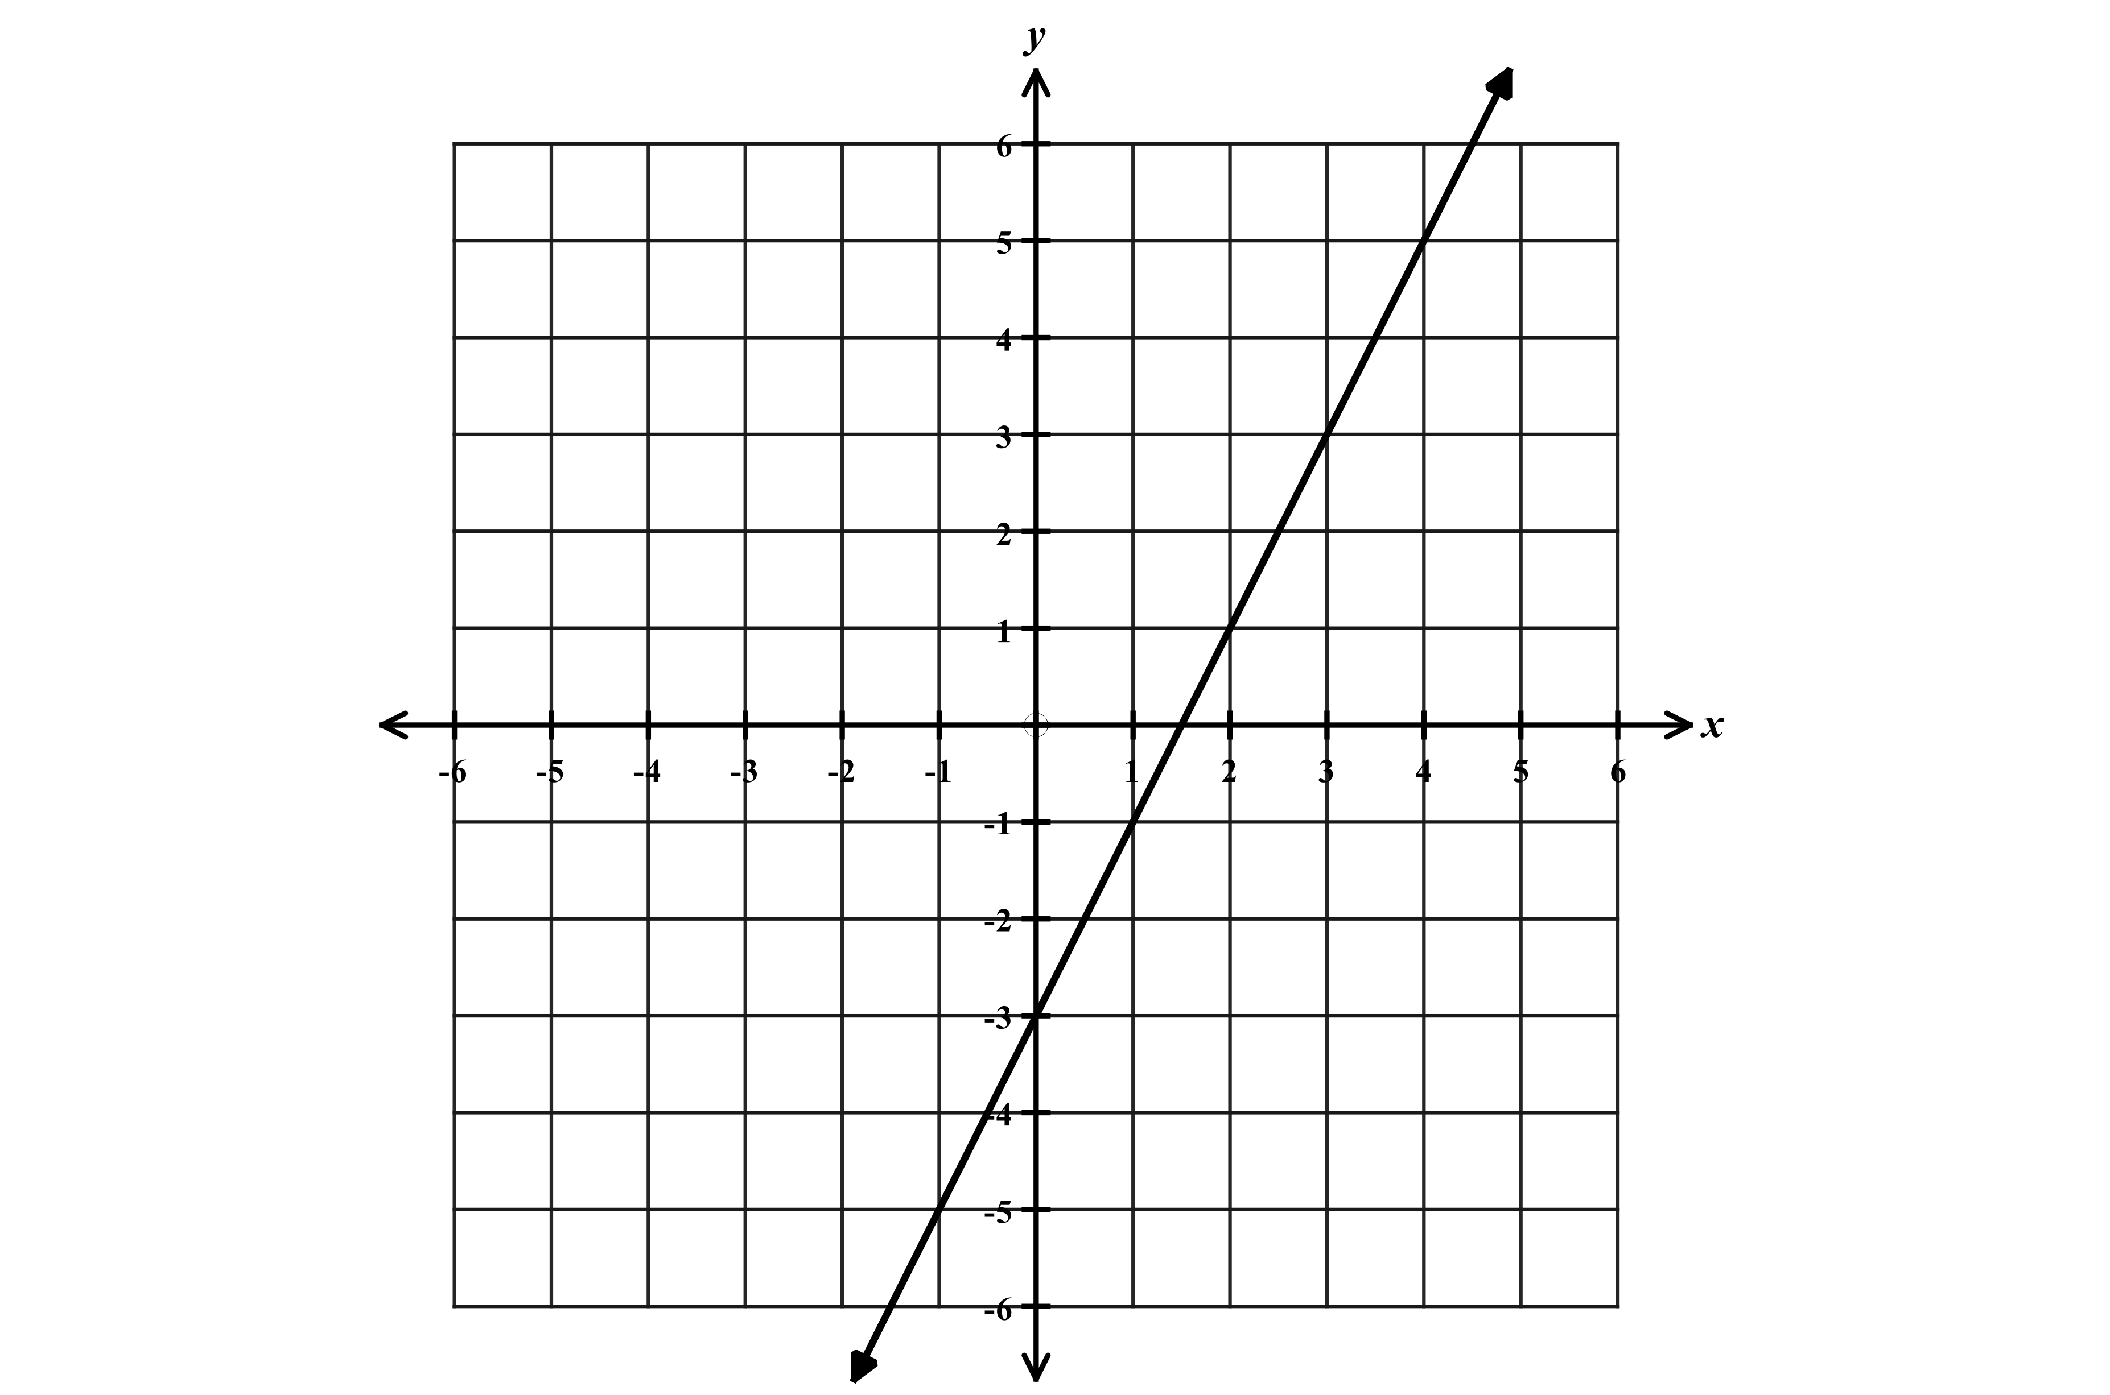  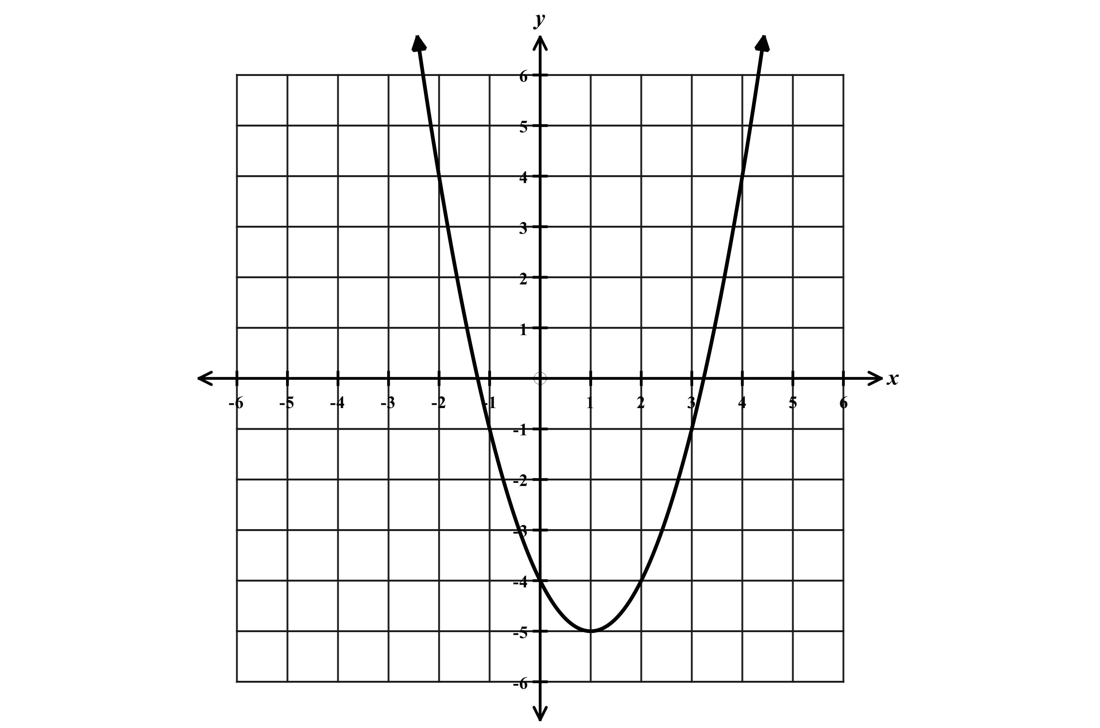  $$y=mx+b$$ | Quadratic  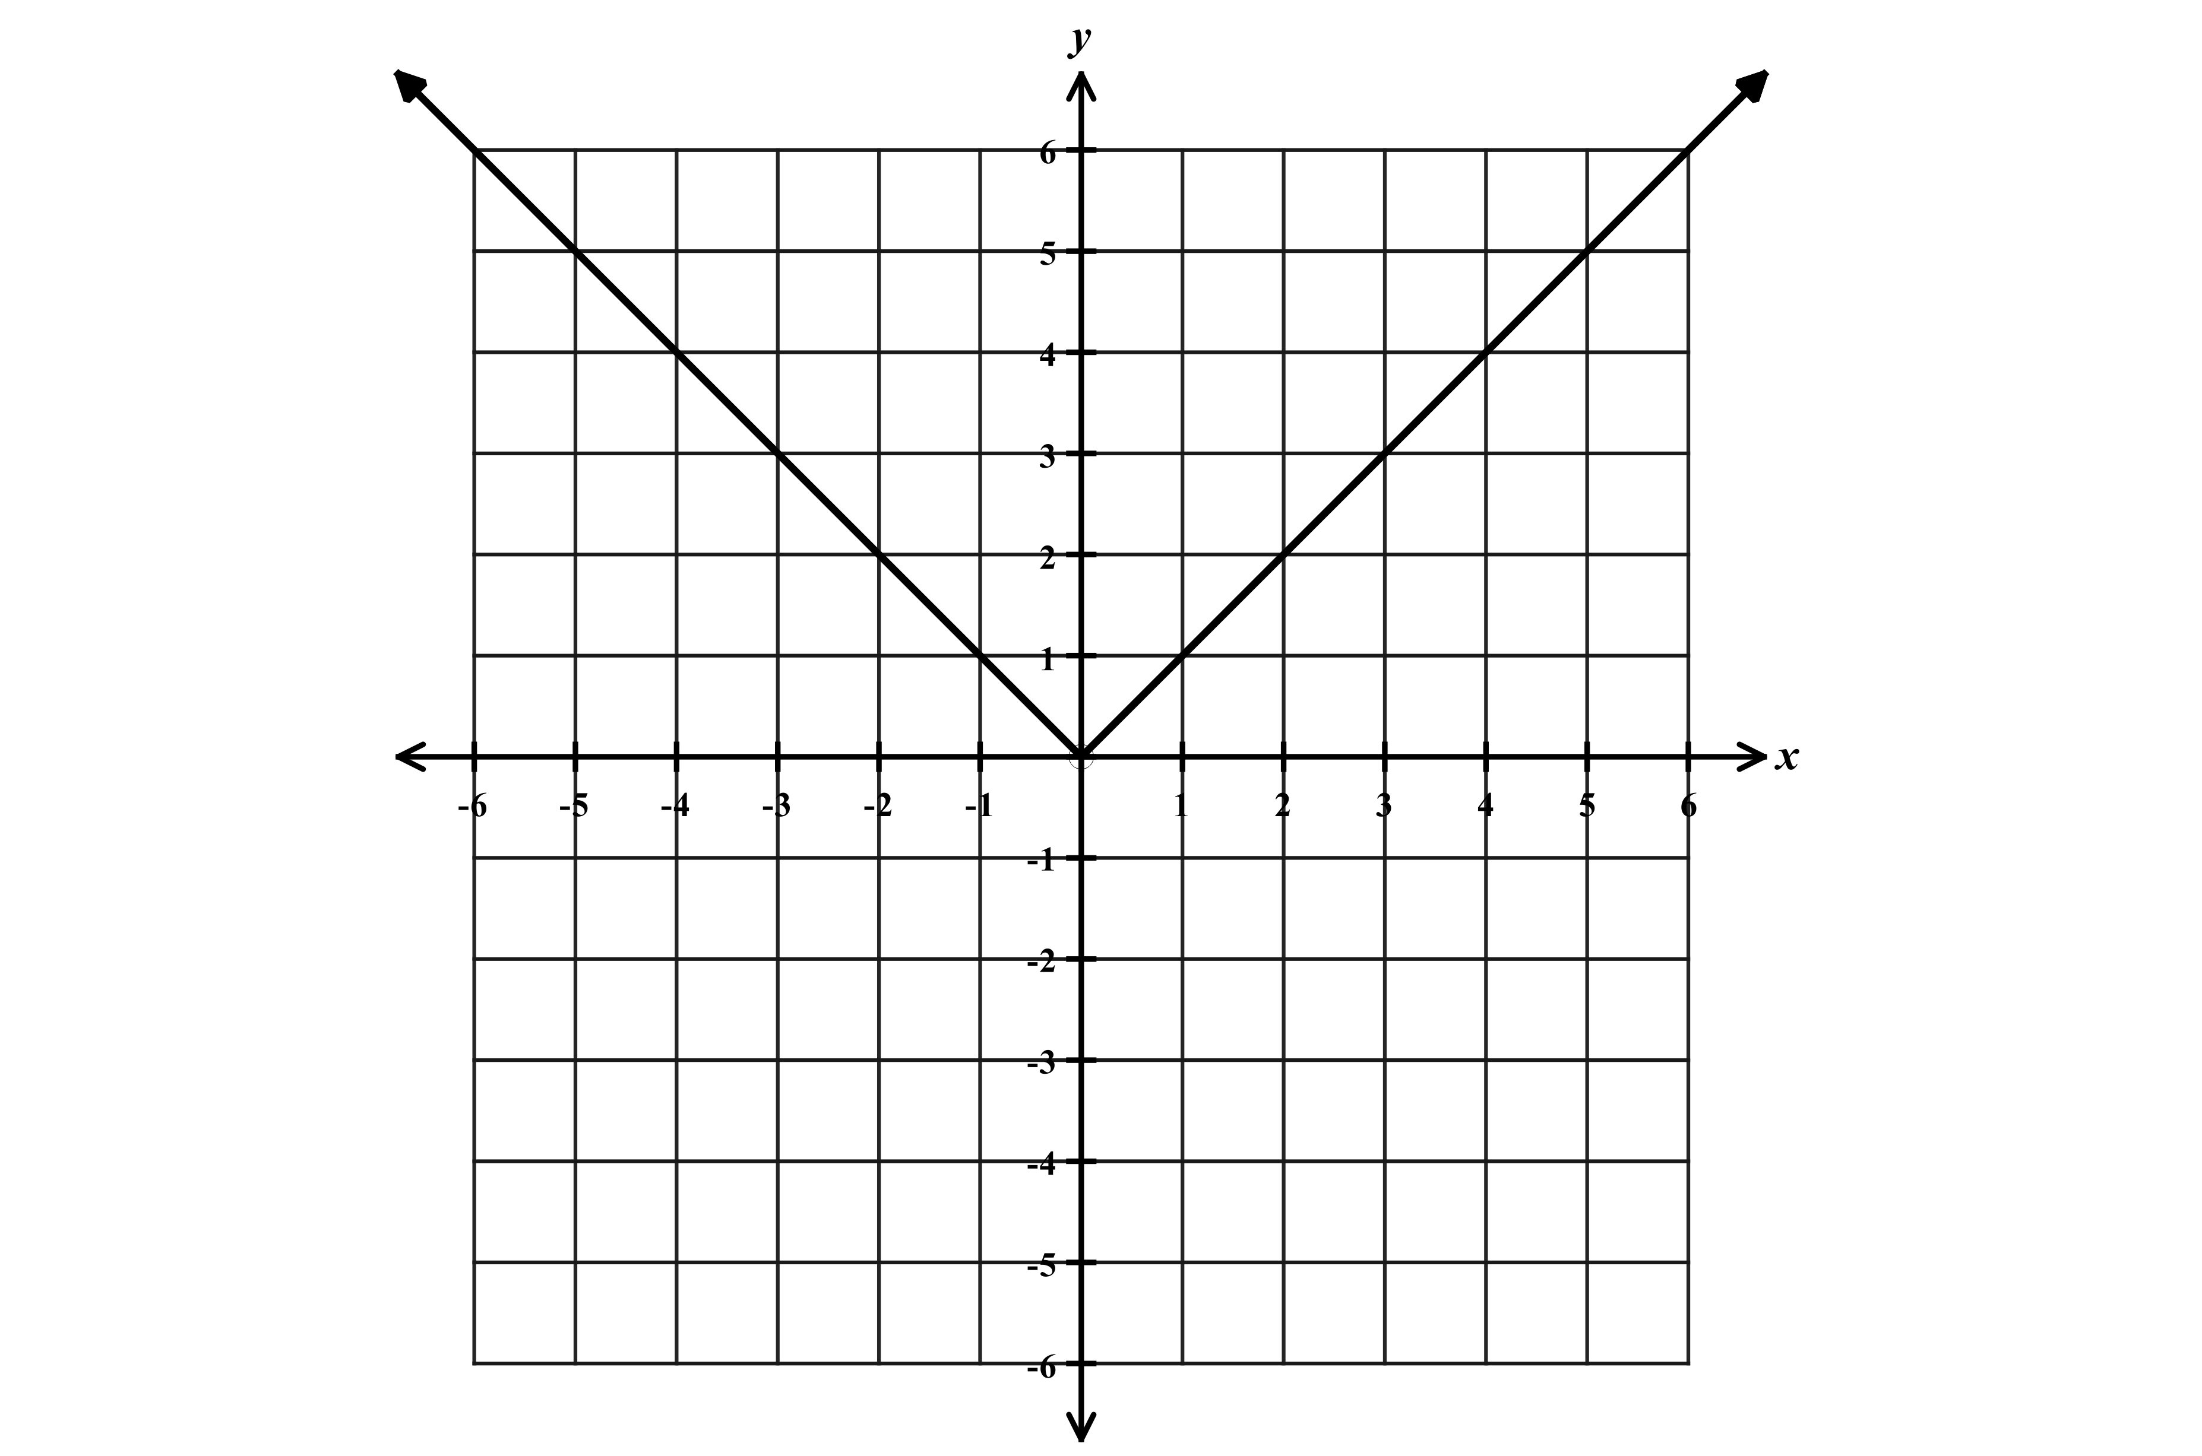  $y=ax^{2}+bx+c$ or $y={a(x-h)}^{2}+k$ | Absolute Value  $$y=a\left|x-c\right|+d$$
Exponential  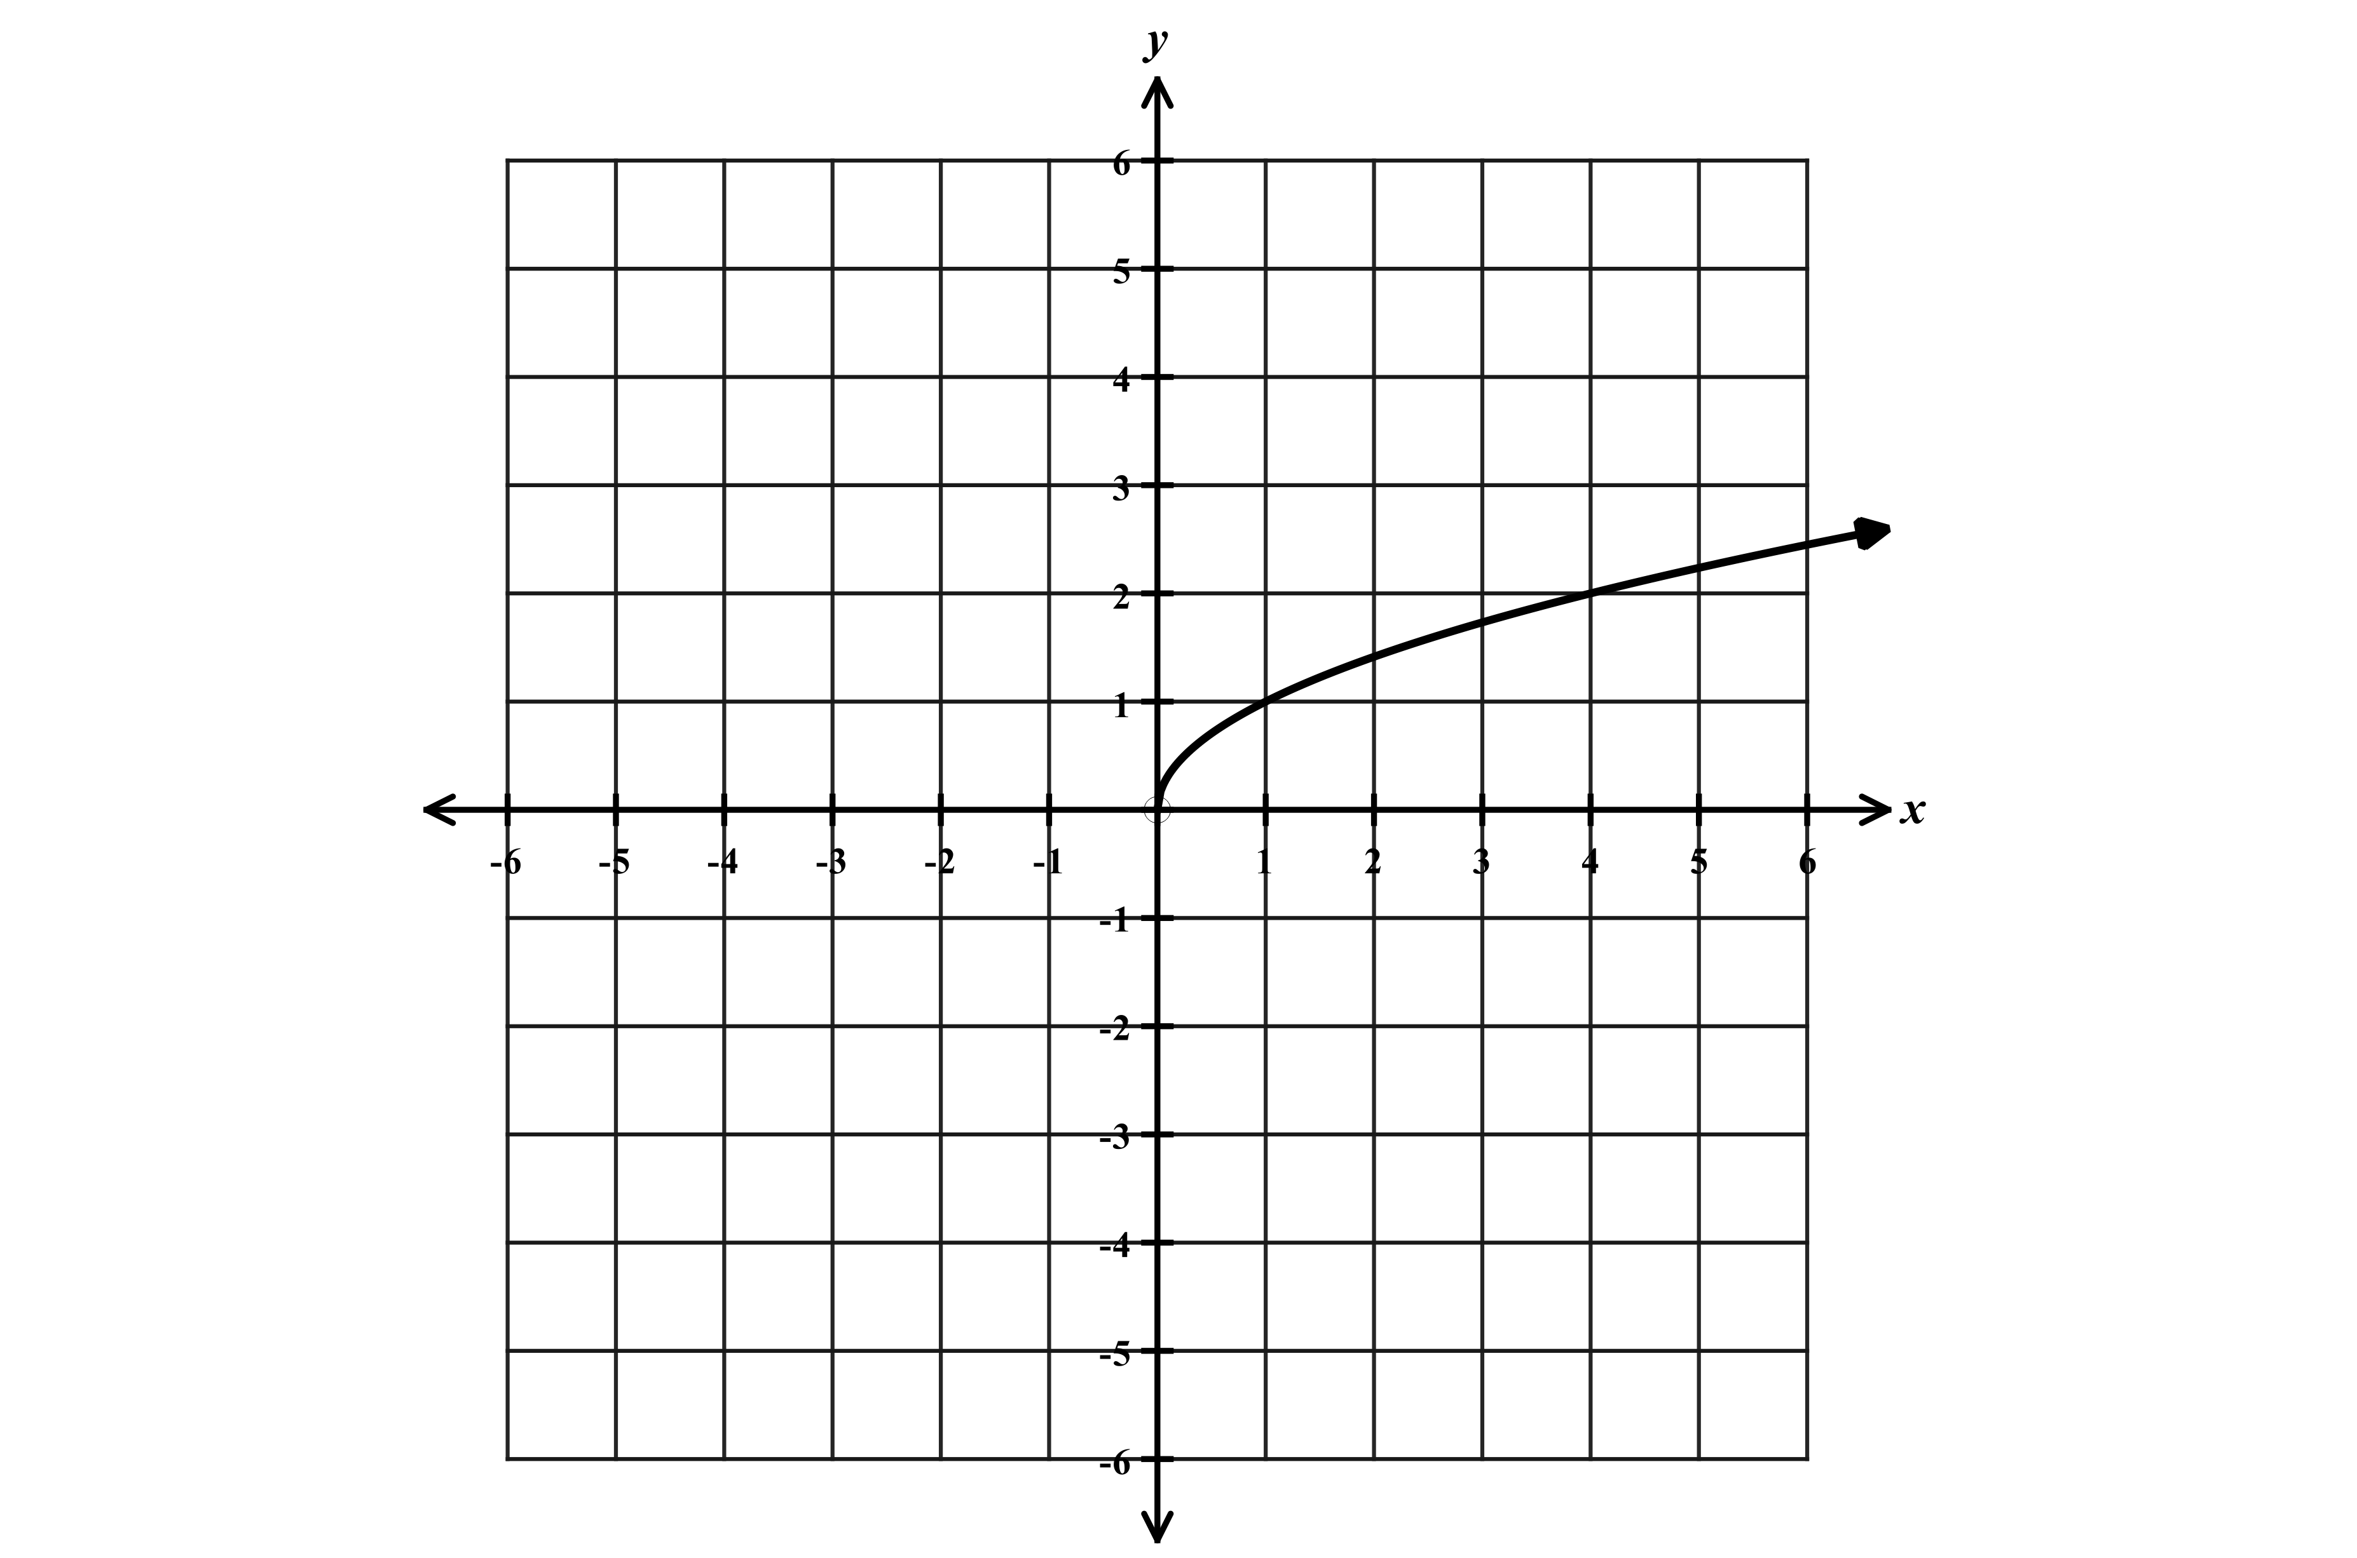  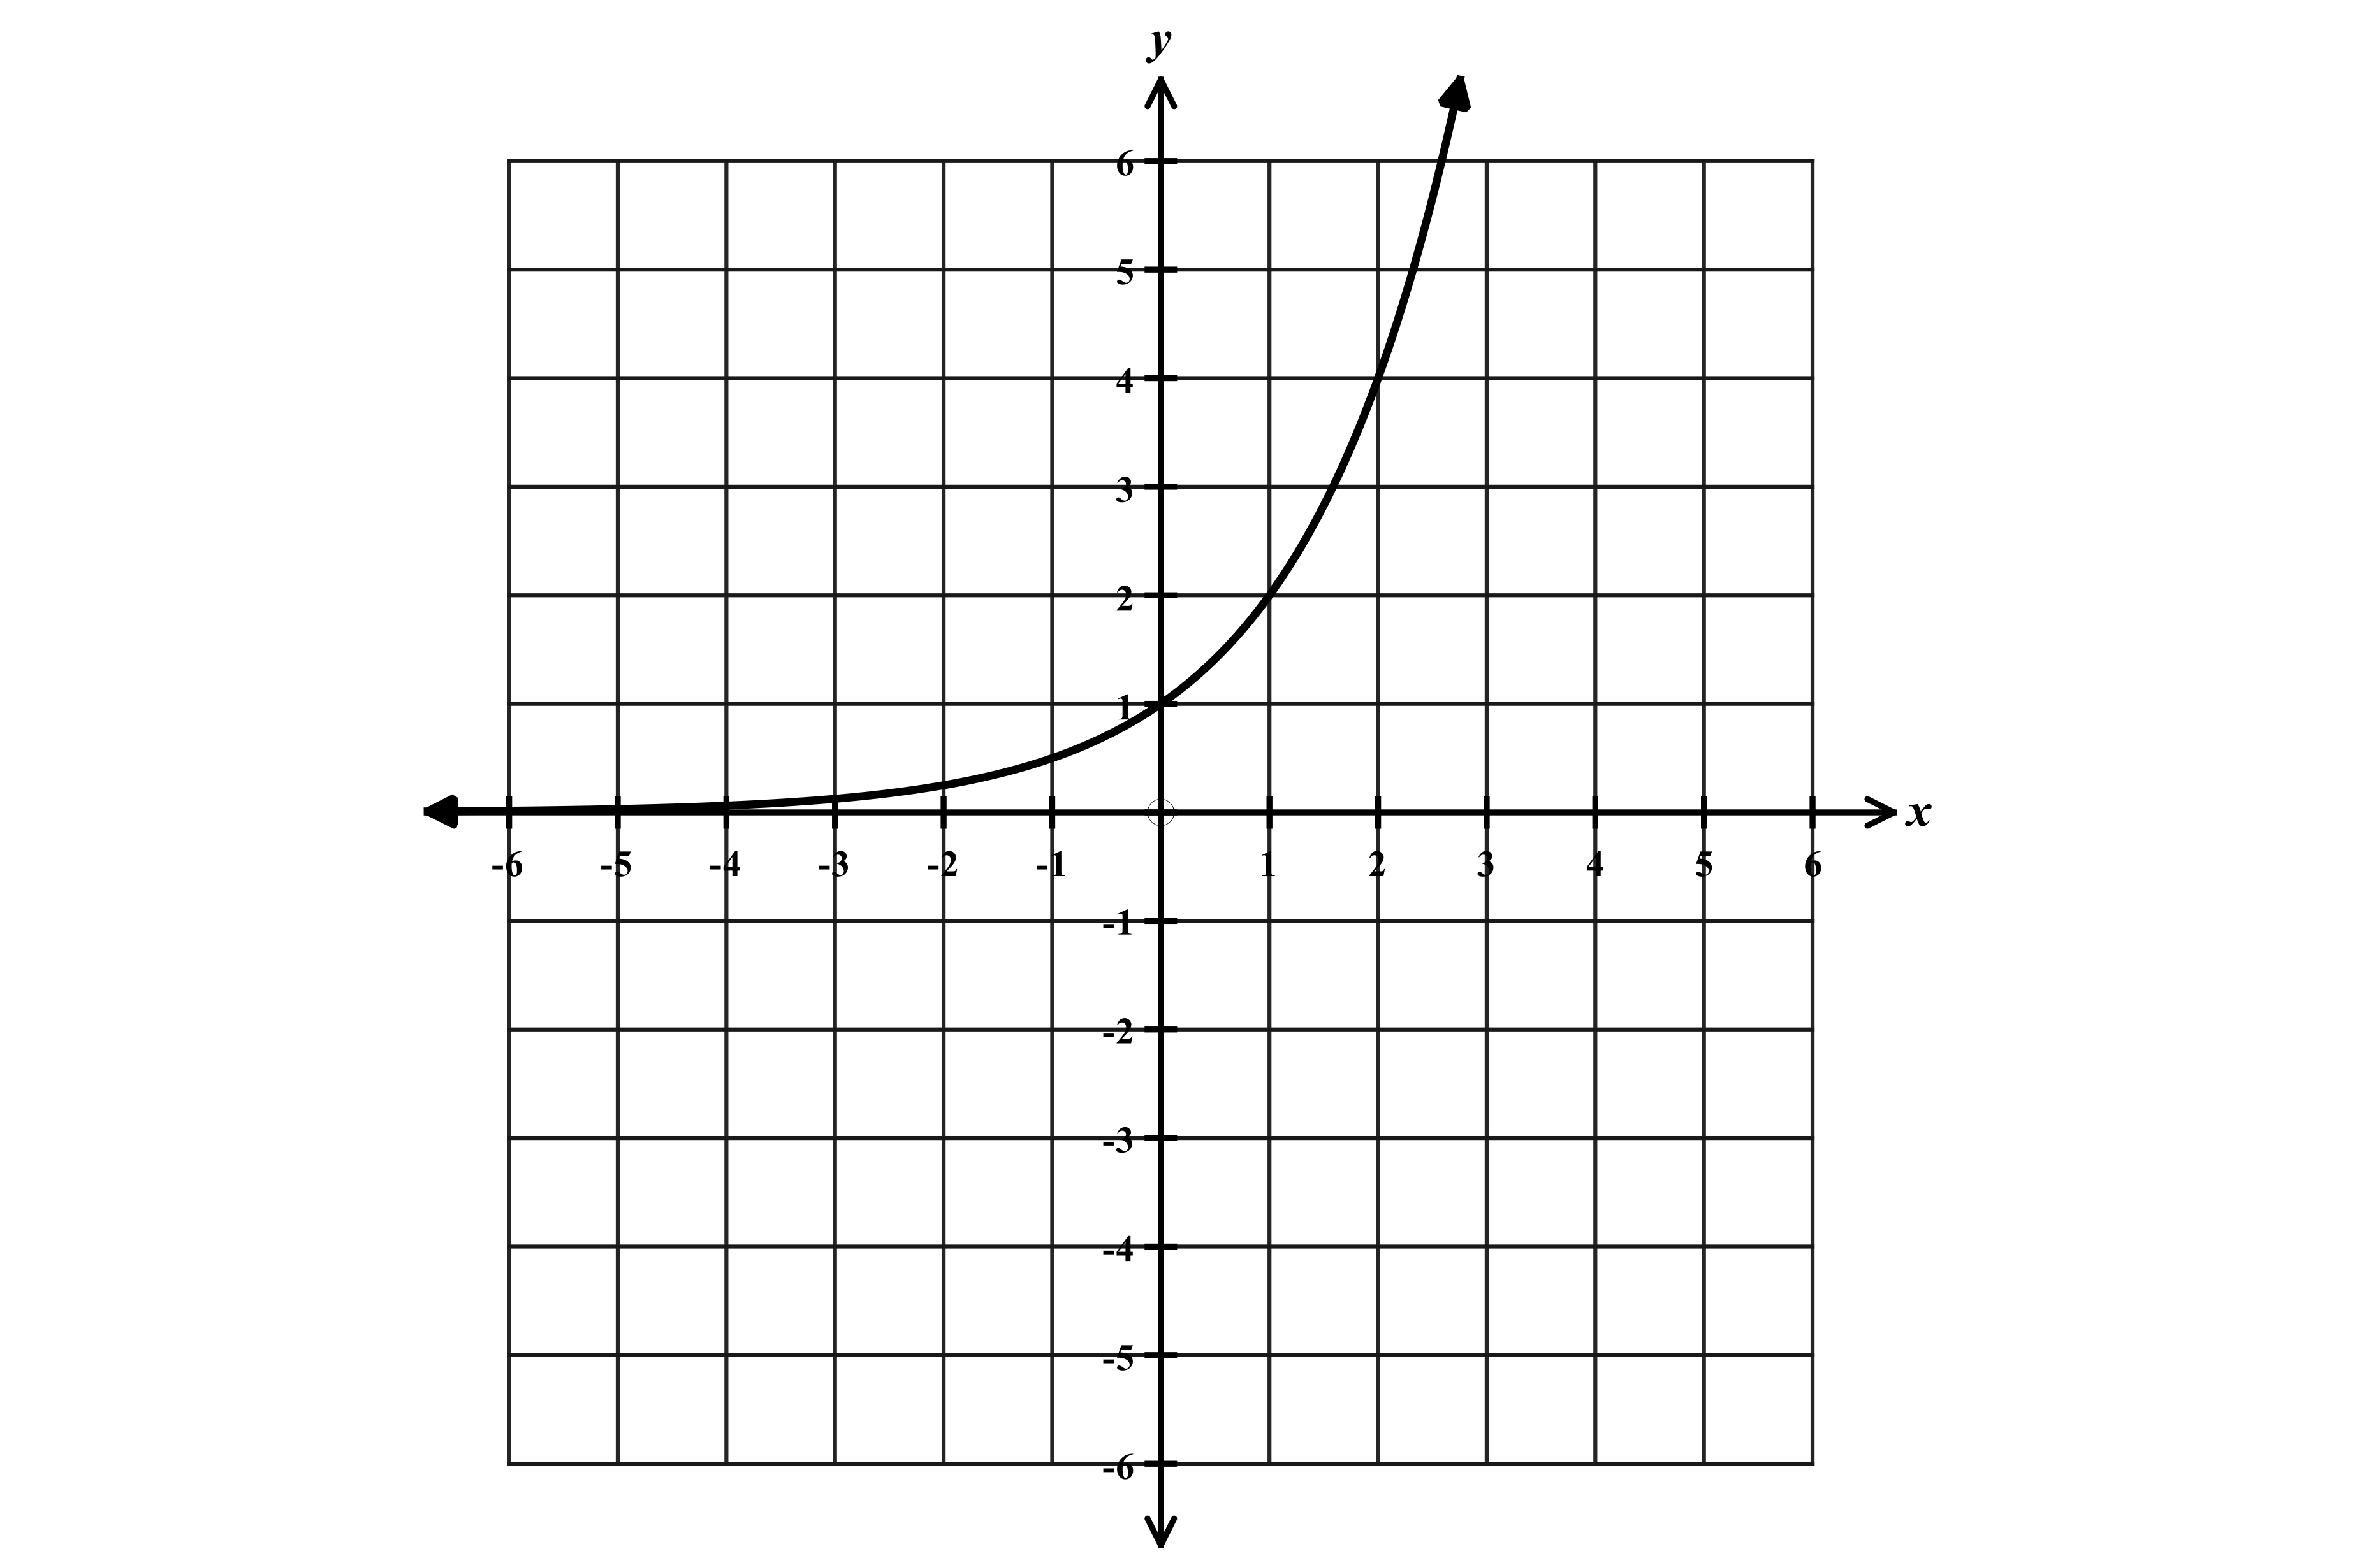  $$y=a{(b)}^{x}$$ | Square Root  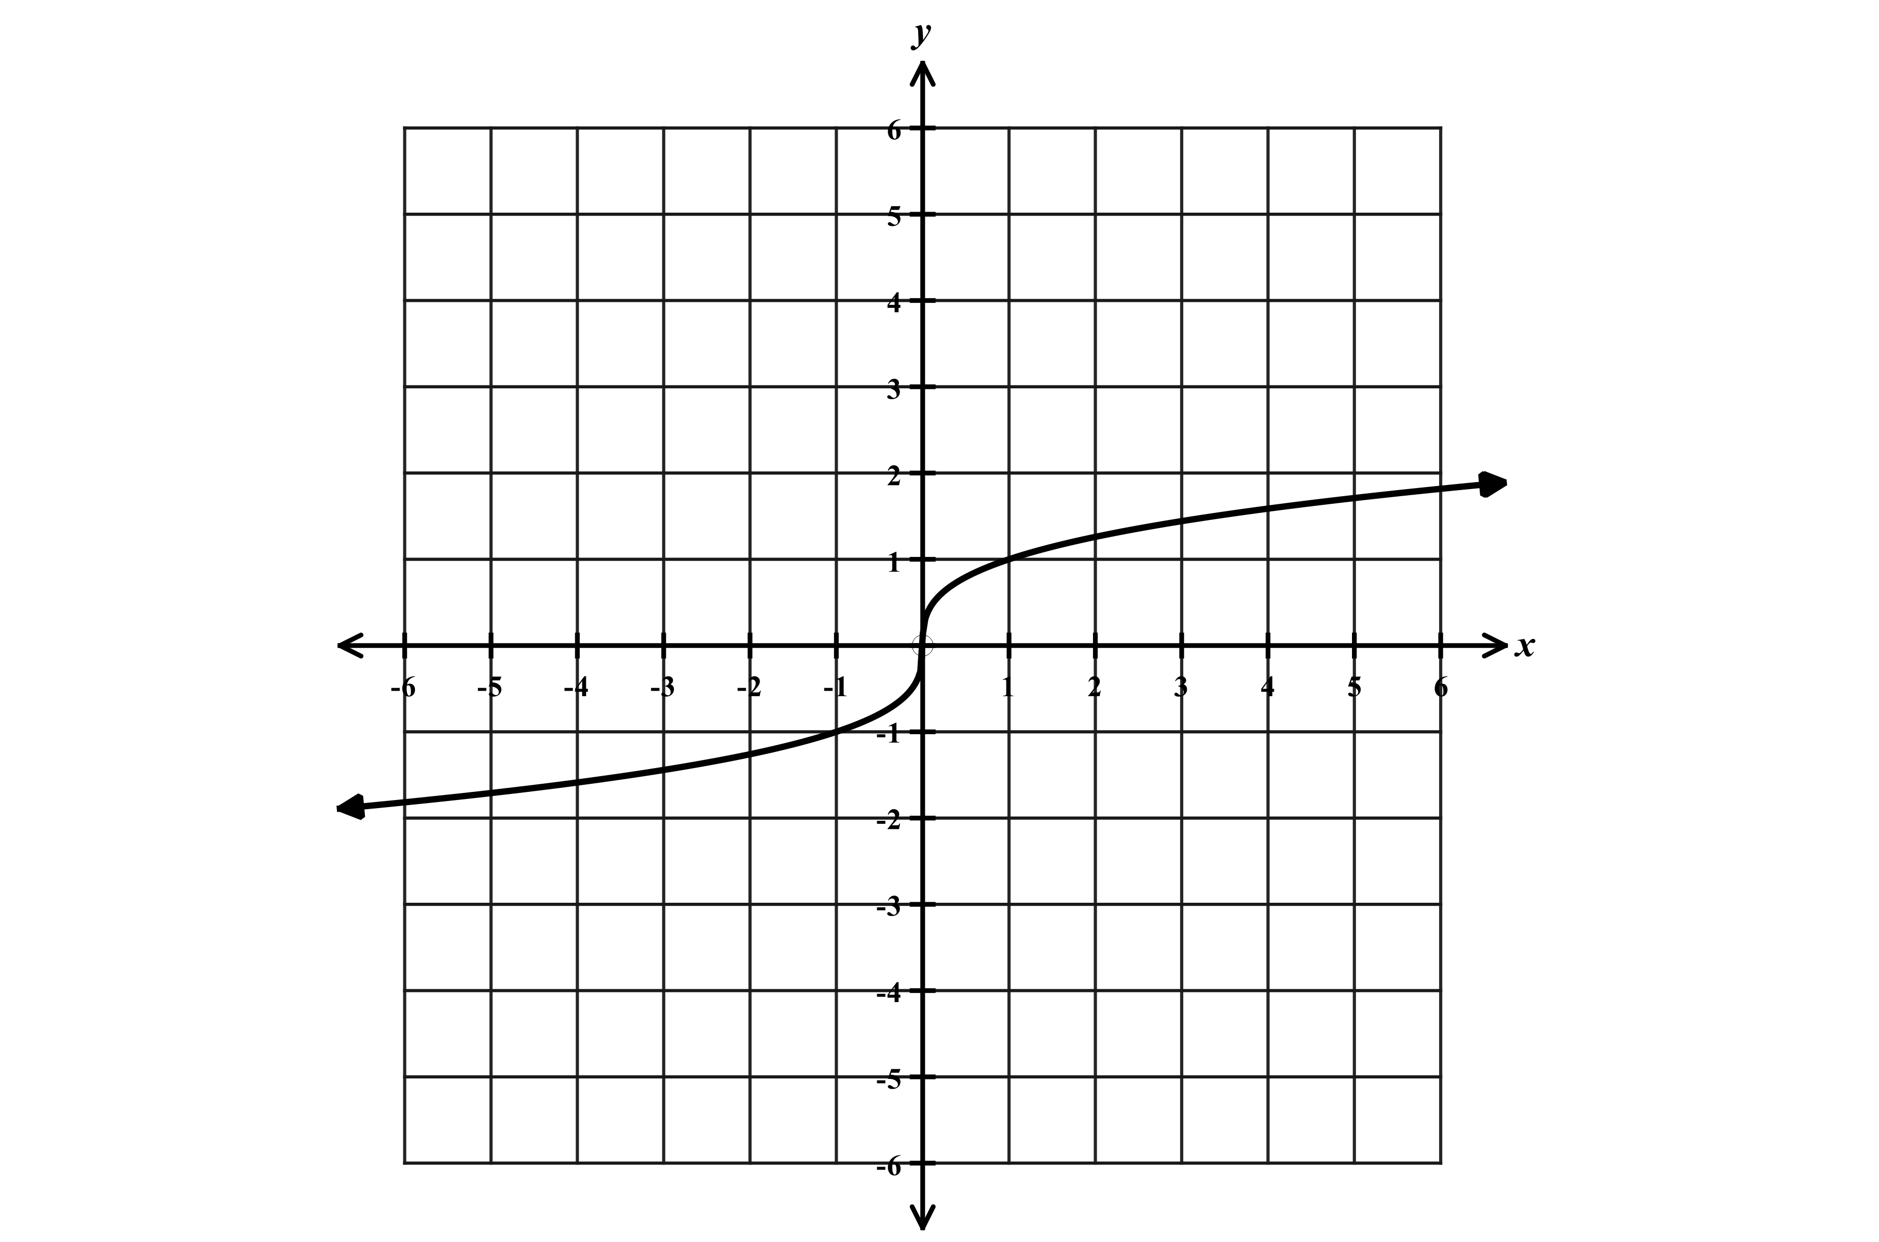  $$y=a\sqrt{x-c}+d$$ | Cube Root  $$y=a\sqrt[3]{x-c}+d$$

Exercise #1
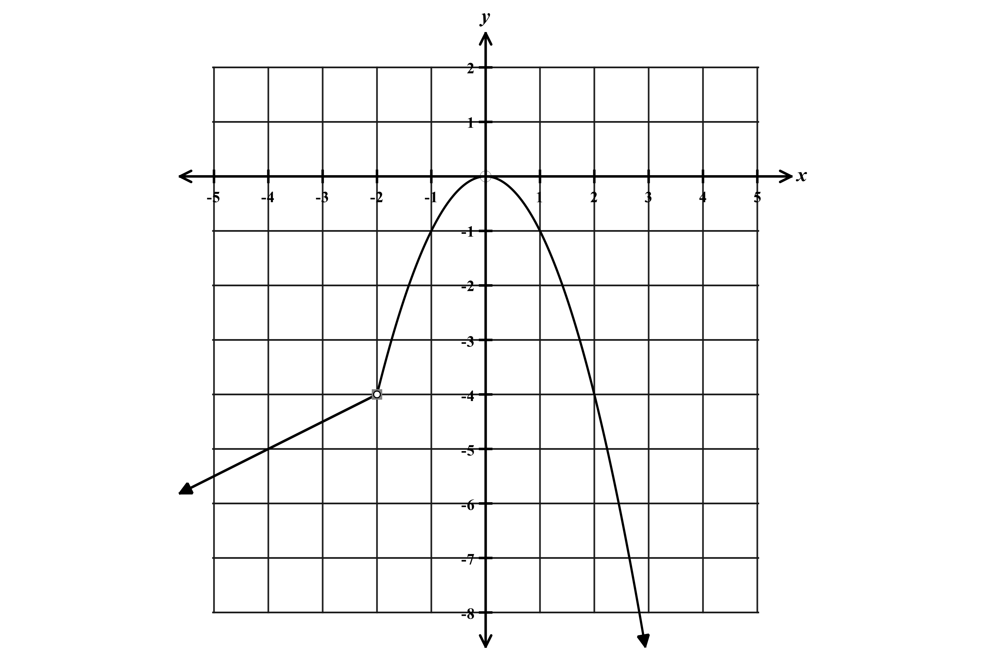
Consider the function graphed to the right.

A. What type of function is graphed over the interval $x<-2?$

B. What type of function is graphed over the interval $x>-2?$

C. Write this function defined as a piecewise function.

$f\left(x\right)=$

D. Over what interval is the function decreasing?
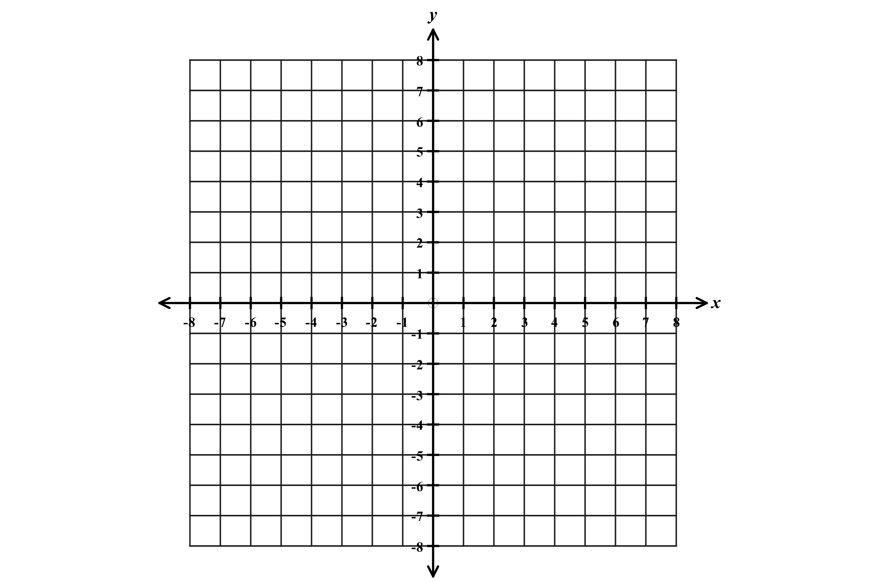
Exercise #2

Consider the function defined below.

5 , $-8≤x<-3$
$f\left(x\right)=$
$|x|$ , $-3≤x≤6$

A. What type of function is defined over the interval $-8≤x<3?$

B. What type of function is defined over the interval $-3≤x<6?$

C. Graph the function on the grid provided.

D. Over what interval is the function decreasing?

E. Over what interval is the function increasing?

Exercise #3

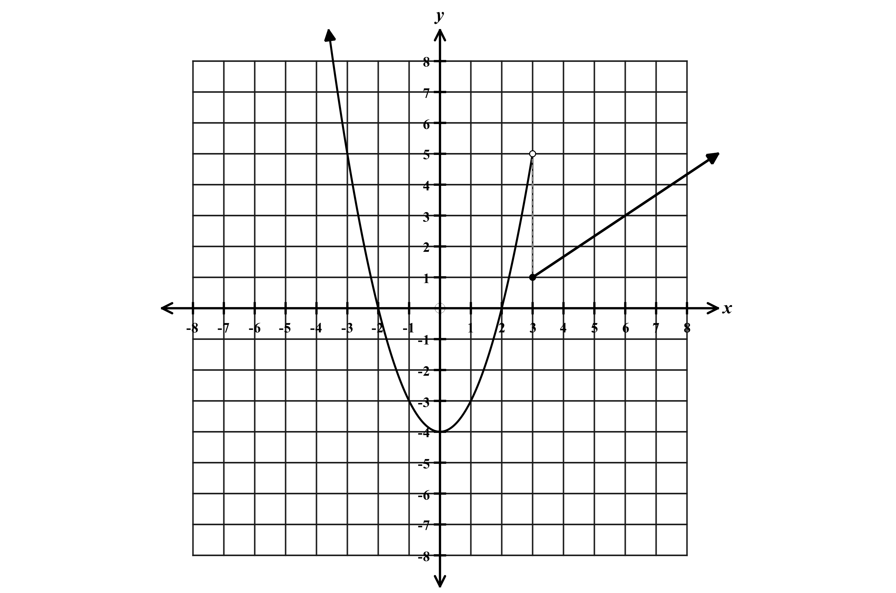
Consider the function shown on the graph to the right.

A. Write the function rule below.

$f\left(x\right)=$

B. Over what interval(s) is $f\left(x\right)$increasing?

C. Over what interval(s) is $f(x)$ decreasing?

D. Over what interval is $f\left(x\right)<0?$

E. What are the zeros (roots) of $f\left(x\right)?$
Exercise #4
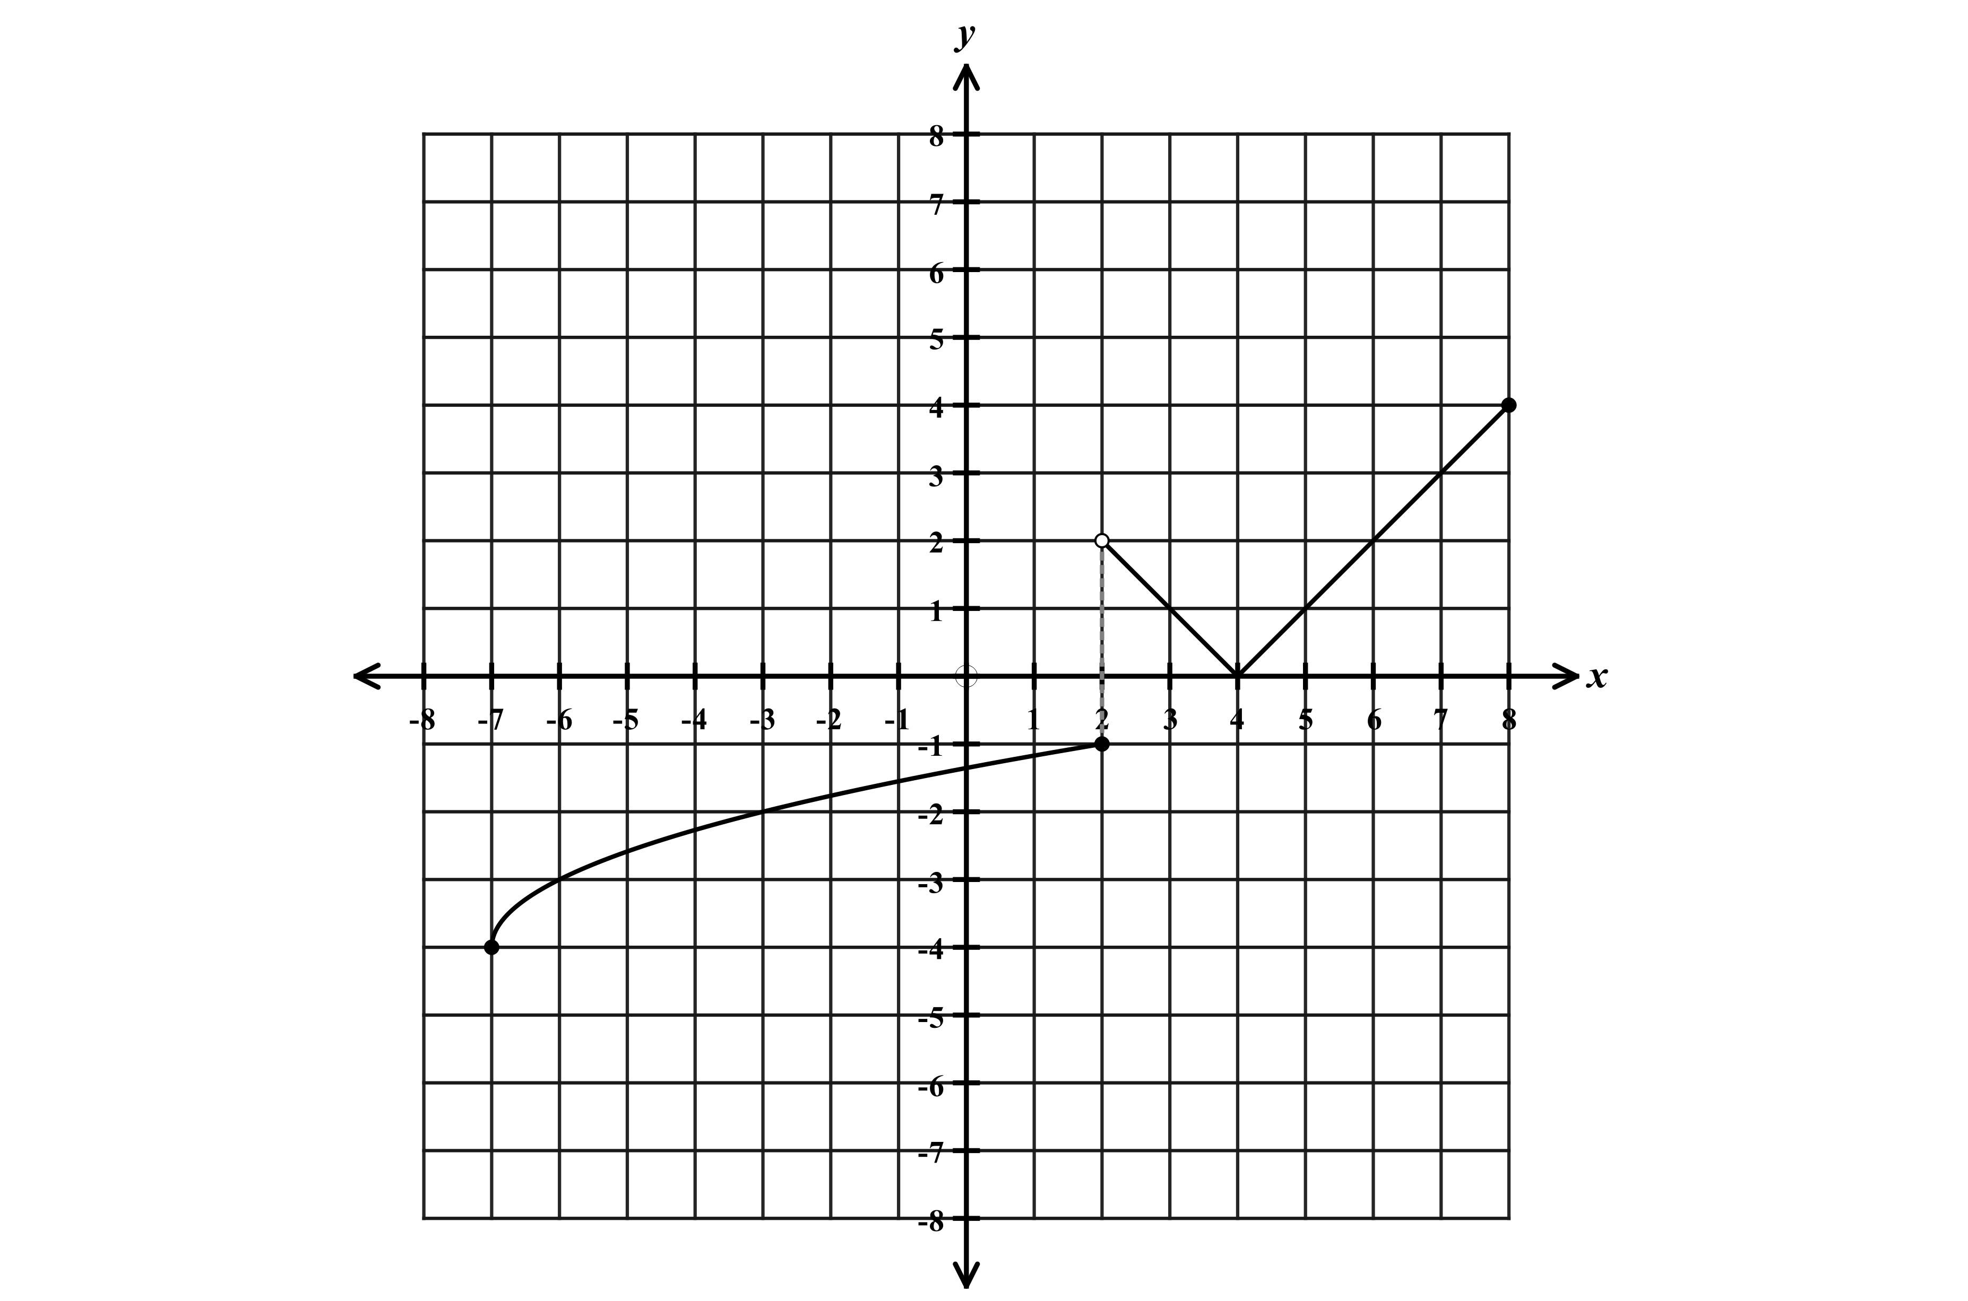
Consider the function shown on the coordinate plane to the right.

A. What two types of functions make up this piecewise graph?

B. Write the function rule below.

$f\left(x\right)=$

C. Over what interval(s) is the function increasing?

D. Over what intervals is the function decreasing?

E. Over what interval is $f\left(x\right)<0?$

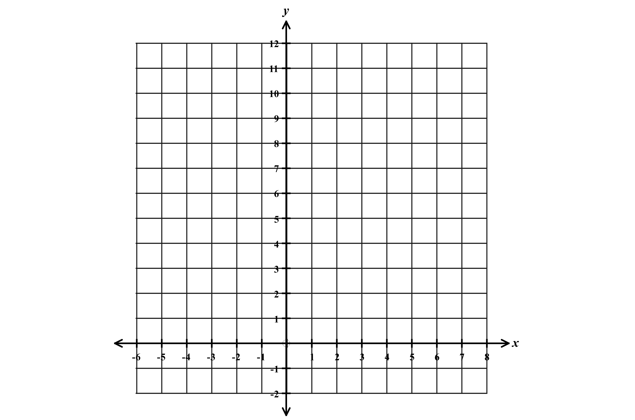
Exercise #5

Consider the function defined below.

$2^{x}$ , $-3≤x≤3$
$f\left(x\right)=$
$11-x , x≥3$

A. What two types of functions are defined in this function rule?

B. Graph the function on the coordinate plane provided.

Homework

Exercise #1
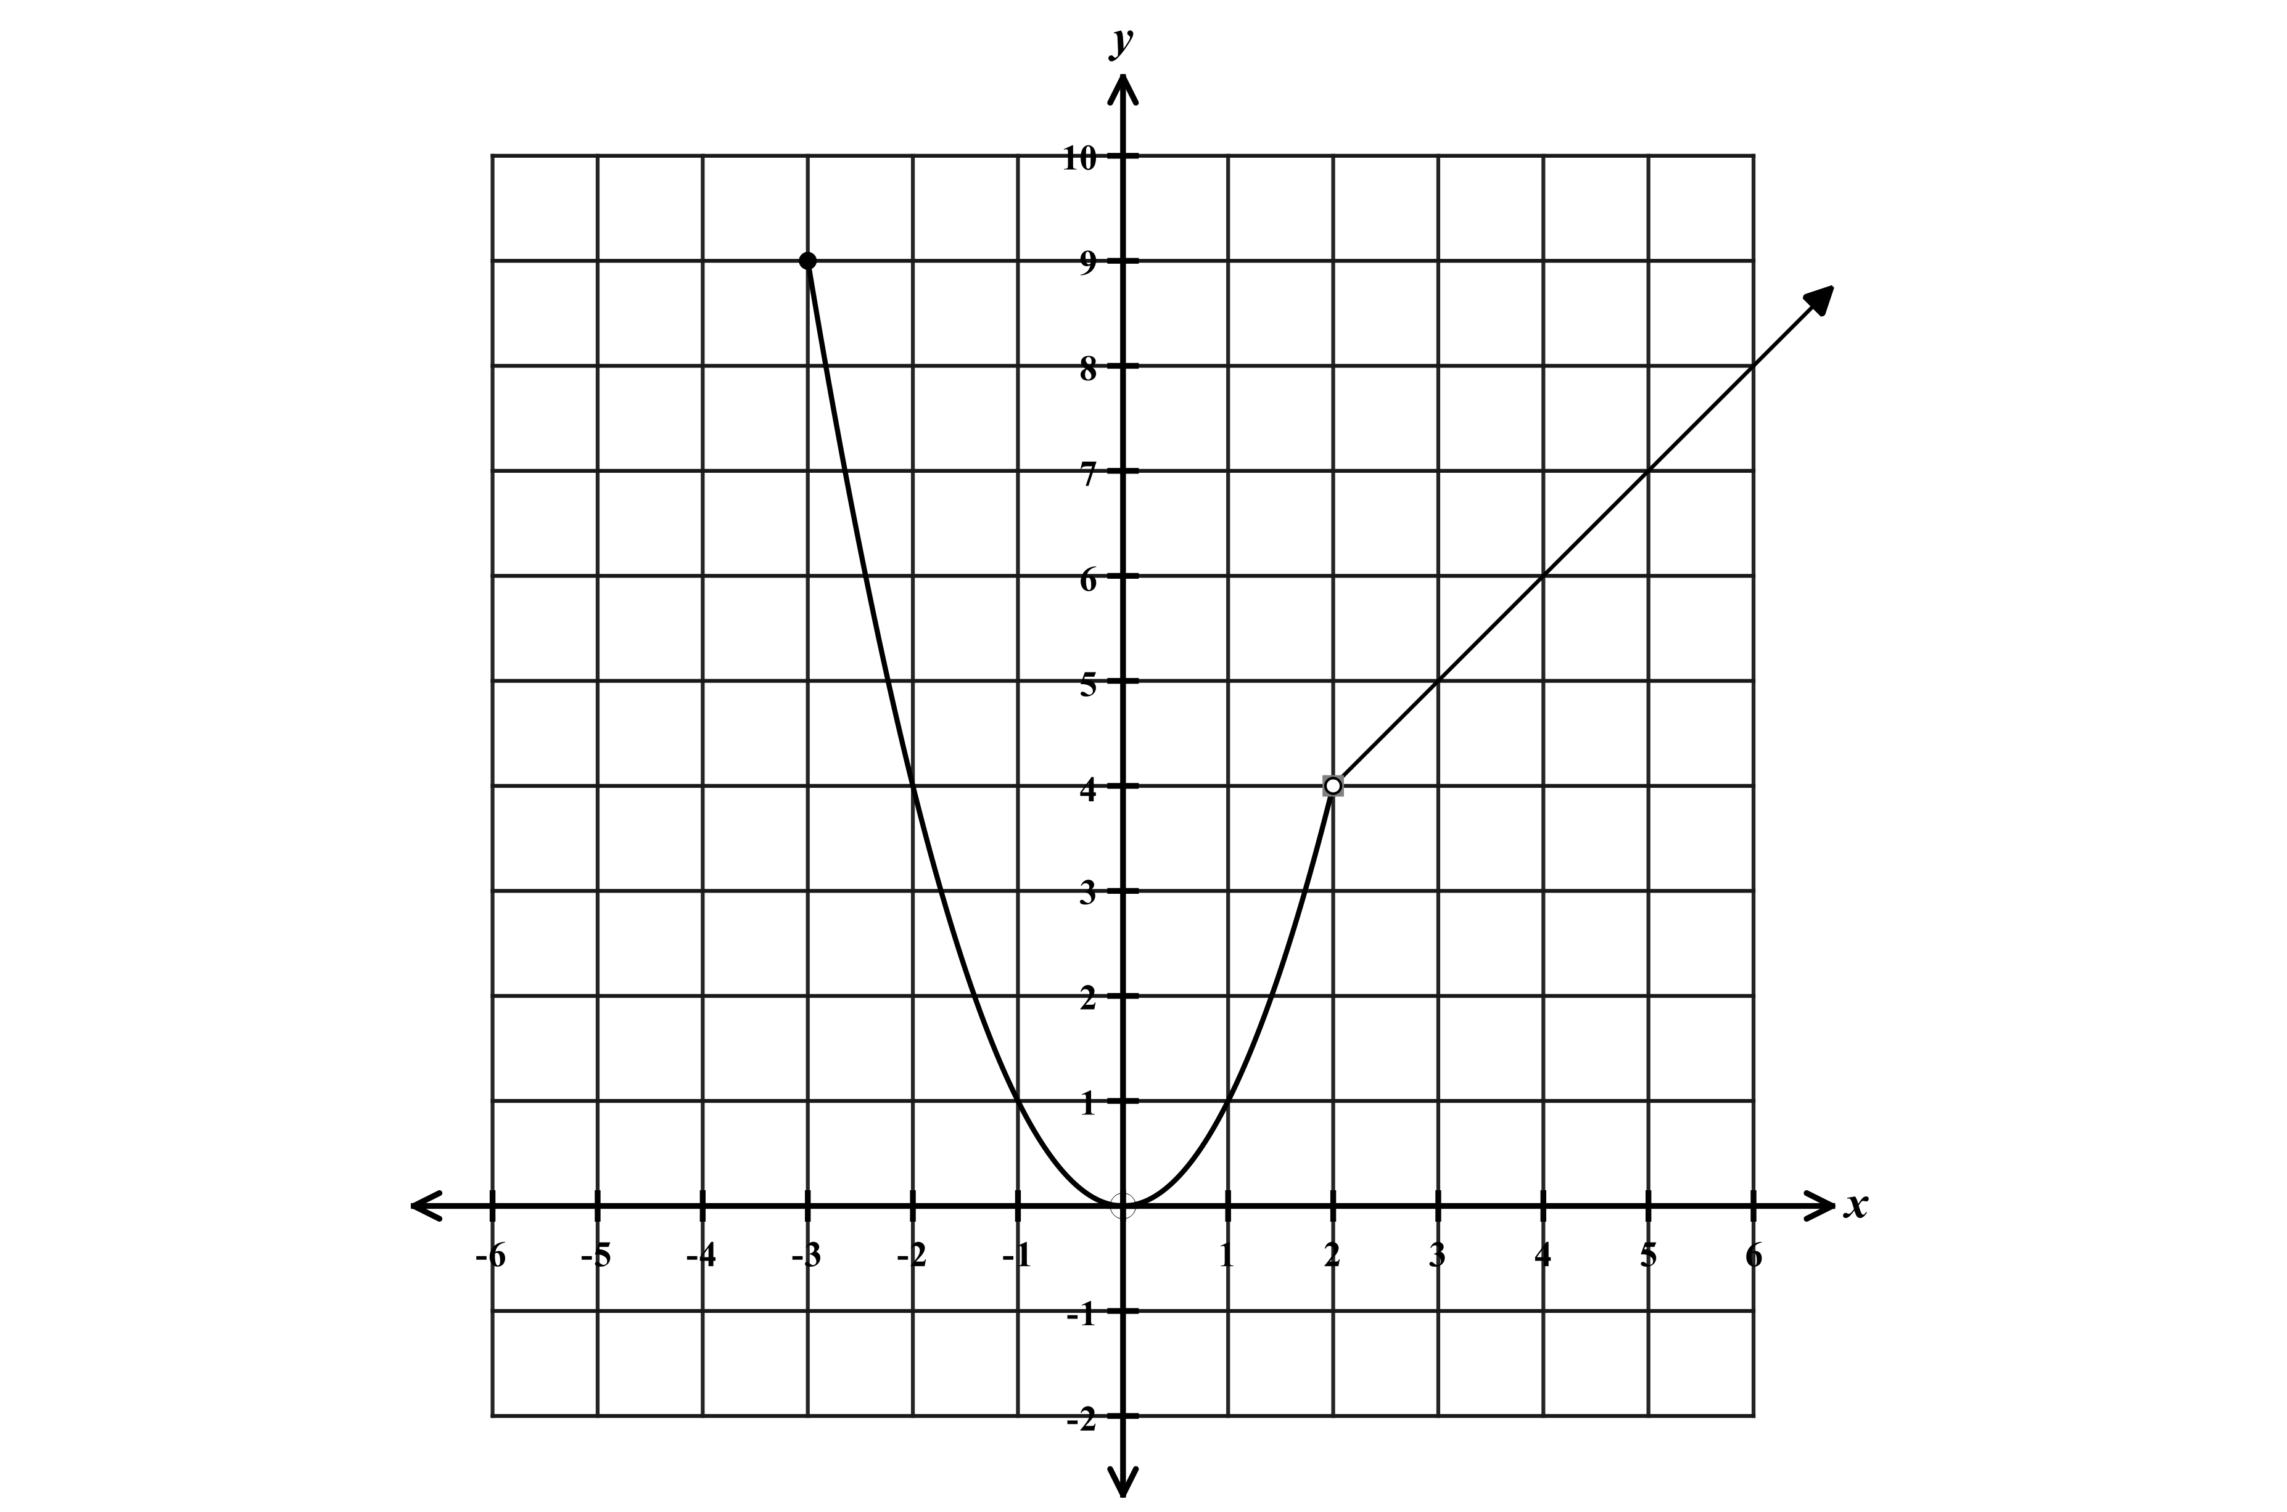

Consider the function graphed to the right.

A. What type of function is graphed over the interval $x<2?$

B. What type of function is graphed over the interval $x>2?$

C. Write this function defined as a piecewise function.

$f\left(x\right)=$

D. Over what interval is the function decreasing?

Exercise #2

Consider the function defined below.
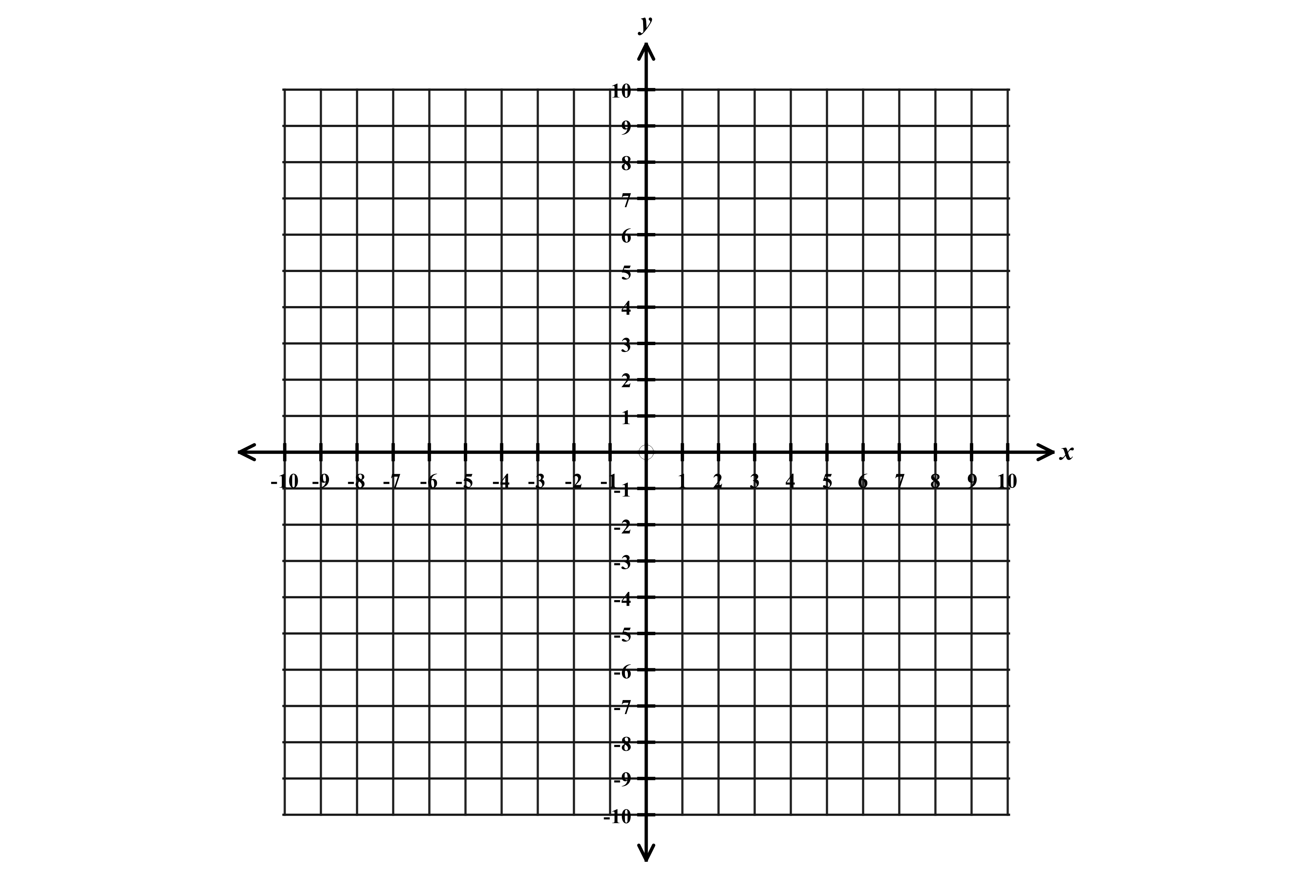

$|x+6|$ , $-10≤x≤-2$
$f\left(x\right)=$
$-x^{2}+8, x≥-2$

A. What type of function is defined over the interval $-10≤x≤-2?$

B. What type of function is defined over the interval $x≥-2?$

C. Graph the function on the grid provided.

D. Over what interval(s) is the function decreasing?

