India/China Population Lab Name: **Steve**

*For many years China has been the most populous country in the world, however in recent years the population of India has been growing at a faster rate. This means that eventually India will replace China as the world’s most populous country. Your task is to collect data and create two best-fit lines, one for each country. By finding the intersection of these two lines you should be able to predict the year when India will overtake China and what their populations will be at this time.*

STEP ONE

Collect population data for the two countries. Indexmundi.com is a good source, as well as wikipedia). Complete the table below.

|  |  |  |
| --- | --- | --- |
| **Years since 2000** | **Population China (Millions)** | **Population India (Millions)** |
| **0** | **1,262** | **1,014** |
| **2** | **1,284** | **1,045** |
| **4** | **1,299** | **1, 065** |
| **6** | **1,314** | **1,095** |
| **8** | **1,330** | **1,148** |
| **10** | **1,330** | **1,173** |
| **12** | **1,343** | **1,205** |

STEP TWO

Plot your data for the populations of India and China on the graph below. Use a ruler to draw a line through each of the two sets of data. Be sure to create a title, label your equations, and indicate an appropriate unit on your axes!

STEP 3

Be sure to answer all the questions on the following page.

Populations of India and China (in millions of people)

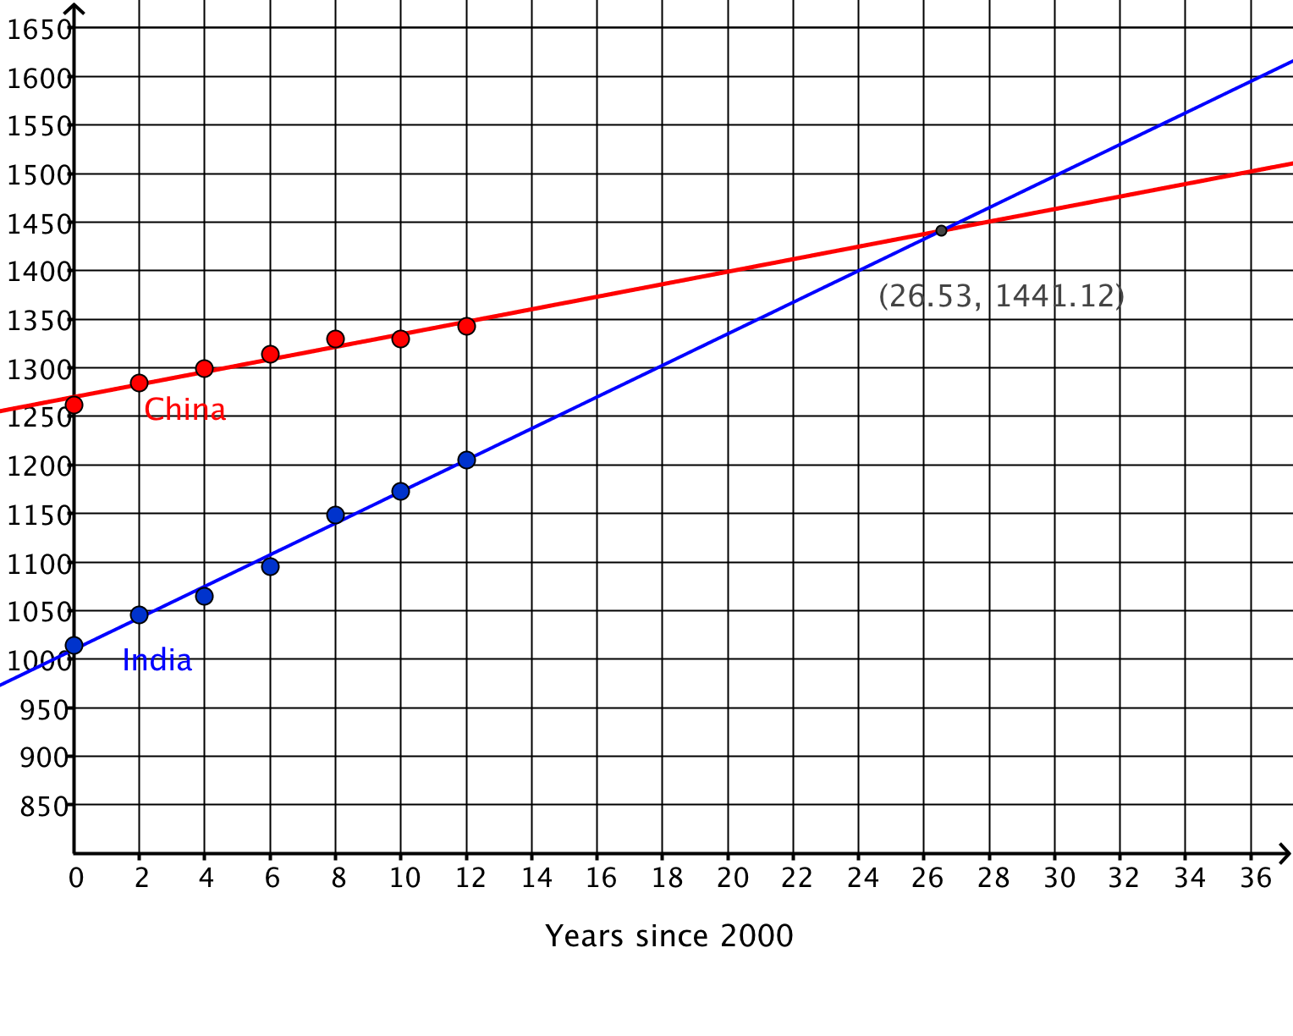

1. Find slopes for the two lines. Use the data from your table.

Slope of China:  Slope of India: 

1. Complete the sentence:

*The country with the fastest growth rate is* **India**

*with a rate of* **19.1** *million people per year.*

1. Write equations for the populations of the two countries. Use the slopes from question #1, and use *y*-intercepts from your table (population for year 2000).

China: *y =* **8.1*x* + 1262**

India: *y =* **19.1*x* + 1014**

1. What do *y* and *x* represent in your equations? (Look at the table!)

*x* is the number of **years** since 2000.

*y* is the number of **people** in millions

1. Find the intersection point of your two lines**: ( 27, 1,441 ).**
2. According to the data, in what year will the population of India begin to exceed the population of China? **In the year 2027 India will pass China.**