Name ________________________________ Period _______ Week of December 8-12
Every day you enter class and complete this assignment. It will count for 15% of your grade. You must hand in every Friday. It will not be accepted late, unless you are absent. If absent, please hand in on Monday. You cannot make up this assignment. Come to extra help, if you have questions.
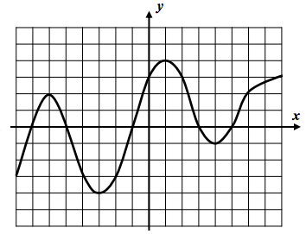
Monday, December 8, 2014 (show your work)
Use the graph to the right to answer parts (a) – (g).
(a) Write the coordinates of all turning points
and indicate if each is a maximum or a minimum
1) turning point ( -6 , 2 ) Maximum or minimum
2) turning point ( , ) Maximum or minimum
3 ) turning point ( , ) Maximum or minimum
4) turning point ( , ) Maximum or minimum
Tuesday, December 9, 2014 (show your work)
(b) Find all solutions to f (x) = -3 Does this mean x = -3 or Does this notation mean y = -3?

Wednesday, December 10 , 2014
C) Over the interval [ -3, 1] is the function increasing or decreasing?_______________________

D ) Give an interval where the function is positive. ________________
Thursday , December 11, 2014
e) Evaluate each of the following: f (-5) = __________ f (6) = __________

(f) State the domain and range of this function.

Domain: Range:

Friday, December 12, 2014

(g) Find the average rate of change from $x=1$ to $x=4$.

