Name ________________________________ Period _______ Week of December 15-19
Every day you enter class and complete this assignment. It will count for 15% of your grade. You must hand in every Friday. It will not be accepted late, unless you are absent. If absent, please hand in on Monday. You cannot make up this assignment. Come to extra help, if you have questions.
Monday, December 15, 2014 (show your work)
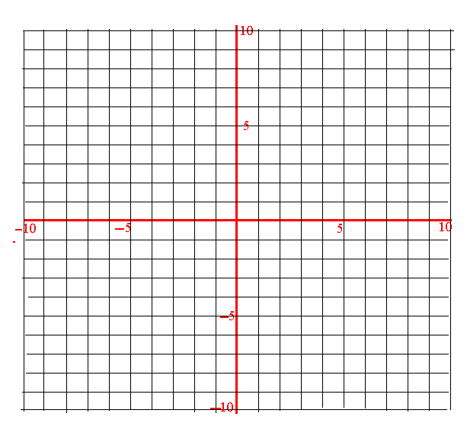
Graph f(x) = x² – 2x – 8 on the coordinate plane below. Use the graph to answer parts (a) – (g).
Tuesday, December 16, 2014 (show your work)
(a) Is this a function? Explain why.

b) State the domain ________________
c) State the range ________________
Wednesday, December 17 , 2014
d) Over the interval [ 1, ∞) is the function increasing or decreasing? _____________

Thursday , December 18, 2014
e) Evaluate each of the following: f (-3) = __________ f (4) = __________

f) State the y- intercept(s) __________________ state the x-intercepts ____________________
Where is y= 0? At x = ________________ and at x = _________________
Friday, December 19, 2014
(g) Find the average rate of change from $x=1$ to $x=4$.

